
Gisma University of Applied Sciences
Department of Computer Science

Evaluating AI-Driven Product Recommendation Systems Using Sentiment and Rating-Based Consumer Evaluation


Dhruv Dharwal
GH1035710
Submitted in partial fulfillments of the requirements for the degree of
Masters of Data Science, AI and Digital Business

Under the supervision of
Amirhossein Jamalian

Abstract
Product recommendation systems play an important role in supporting personalized decision making within e-commerce platforms by helping consumers identify relevant products from increasingly large catalogues. However, the effectiveness of recommendation systems depends strongly on how product information is represented and how semantic relationships between products are identified. Traditional text-based approaches such as Term Frequency–Inverse Document Frequency (TF-IDF) can provide computationally efficient representations but may have difficulty capturing contextual and semantic similarities between products.
This thesis focuses on performing a comparative assessment between two different approaches of recommending products using text processing techniques. One of them relies on TF-IDF feature encoding along with cosine similarity computation, whereas the other one involves a transformer-based model for semantic textual embedding. Language models based on transformers serve as a substitute solution because of their ability to generate context-aware embedding’s of semantically related but not necessarily similar texts. The analysis is performed using the Amazon Fashion dataset.
Customer review information is aggregated at product level before generating recommendations through similarity-based retrieval. The findings provide an empirical comparison of lexical and semantic recommendation approaches under a common experimental framework.
The research brings into light the influence of diverse text representation methods on recommendation relevance, coverage, and diversity, along with emphasizing the difficulties that can arise when attempting to evaluate recommendations without the presence of exposure, click, and purchasing histories
Keywords: product recommendation systems, artificial intelligence, TF-IDF, transformer embedding’s, cosine similarity. E-commerce, recommender systems

Dataset Link: https://www.kaggle.com/datasets/fawadhossaini1415/amazon-fashion-800k-user-reviews-dataset
Github : https://github.com/DDdhruv/Dissertation
Contents
Abstract 2
List of Figures 6
List of Tables 7
Chapter 1 Introduction 8
1.1 Background 8
1.2 Research Problem 9
1.3 Research Gap 10
1.4 Research Aim 11
1.5 Research Objectives 11
1.6 Research Questions 11
1.7 Scope of the Research 12
1.8 Research Contribution 13
1.8.1 Technical Contribution 13
1.8.2 Comparative Contribution 13
1.8.3 Multi-dimensional Evaluation Contribution 13
1.8.4 Consumer-Evaluation Contribution 13
1.9 Significance of the Research 14
1.10 Dissertation Structure 14
Chapter 2 Literature Review, Theoretical Background and Related Work 16
2.1 Introduction 16
2.2 Recommender Systems 16
2.3 Types of Recommender Systems 17
2.3.1 Collaborative Filtering 17
2.3.2 Content-Based Recommendation 17
2.3.3 Hybrid Recommendation 17
2.4 Content-Based Product Recommendation 18
2.5 Customer Reviews as Product Information 18
2.6 Natural Language Processing in Recommendation Systems 19
2.7 TF-IDF 19
2.8 Cosine Similarity 20
2.9 Transformer-Based Language Models 20
2.10 Transformer-Based Semantic Embedding’s 20
2.11 Sentence-Level Semantic Representation 21
2.12 TF-IDF and Transformer-Based Representation 21
2.13 Sentiment Analysis and Rating-Based Consumer Evaluation 22
2.14 Review of Recent Empirical Studies 23
2.15 Critical Comparison of Existing Approaches 23
2.16 Refined Research Gap and Study Positioning 25
Chapter 3 – Methodology and Data Science Approach 27
3.1 Introduction 27
3.2 Research Design and Approach 27
3.3 Dataset and Data Source 28
3.4 Data Preprocessing and Exploratory Analysis 29
3.5 Product-Level Text Representation 30
3.6 TF-IDF and Cosine-Similarity Recommendation Model 30
3.7 Transformer-Based Semantic Recommendation Model 31
3.8 Evaluation Metrics 31
3.9 Recommendation Generation and Relevance Definition 34
3.10 Sentiment and Rating-Based Consumer Evaluation 35
3.11 Statistical Analysis 35
3.12 Ethical Considerations, Methodological Limitations and Chapter Summary 35
3.12.1 Ethical Considerations 35
3.12.2 Methodological Limitations 36
3.12.3 Chapter Summary 36
Chapter 4 – Results and Discussion 38
4.1 Introduction 38
4.2 Dataset and Data Preparation Results 38
4.3 Exploratory Data Analysis 40
4.3.1 Rating Distribution 40
4.3.2 Rating-Derived Sentiment Distribution 41
4.3.3 Review Characteristics 43
4.3.4 Review Characteristics by Rating 44
4.4 Product-Level Analysis 46
4.5 Product Relevance Distribution 46
4.6 TF-IDF and Transformer Representation 47
4.7 Recommendation Performance 48
4.8 Precision@K Results 48
4.9 Recall@K Results 50
4.10 NDCG@K Results 52
4.11 Recommendation Diversity 53
4.12 Catalogue Coverage 55
4.13 Statistical Significance Testing 56
4.14 Overall Recommendation Comparison 57
4.15 Discussion of Research Question 59
RQ1: How effectively can Amazon Fashion customer review text be used to generate content-based product recommendations? 59
RQ2: Does the transformer-based recommendation approach produce different recommendation relevance from the TF-IDF baseline? 59
RQ3: How do TF-IDF and transformer-based approaches differ in Precision@K, Recall@K and NDCG@K? 60
RQ4: How do the two recommendation approaches differ in catalogue coverage and recommendation diversity? 60
RQ5: What relationships exist between customer ratings, rating-derived sentiment and selected review characteristics? 61
4.16 Statistical Evidence for the Observed Differences 62
4.17 Interpretation of the Overall Model Behavior 62
4.18 Relationship between the Results and Consumer Evaluation 63
4.19 Implications of the Findings 64
Chapter 5 – Conclusion, Limitations and Recommendations 65
5.1 Introduction 65
5.2 Conclusions in Relation to the Research Questions 66
5.3 Limitations of the Study 67
5.3.1 Content-Based Recommendation 67
5.3.2 Limited Personalization 67
5.3.3 Sparse Product-Level Information 67
5.3.4 Rating-Based Relevance 68
5.3.5 Single Transformer Model 68
5.3.6 Offline Evaluation 68
5.3.7 Recall Measurement 68
5.4 Recommendations for Future Research 69
5.5 Practical Recommendations 70
5.6 Final Conclusion 70
References 72

List of Figures
Figure 1.1 — Structure of the Dissertation
Figure 3.1 — Research Methodology Framework
Figure 3.2 — Product Recommendation System Architecture
Figure 3.3 — Data Preprocessing and Product-Level Text Representation Pipeline
Figure 3.4 — TF-IDF-Based Recommendation Process
Figure 3.5 — Transformer-Based Semantic Recommendation Process
Figure 4.1 — Distribution of Product Reviews
Figure 4.2 — Distribution of Review Ratings
Figure 4.3 — Precision@K Comparison
Figure 4.4 — Recall@K Comparison
Figure 4.5 — NDCG@K Comparison
Figure 4.6 — Catalogue Coverage Comparison
Figure 4.7 — Recommendation Diversity Comparison
Figure 4.8 — Comparative Performance of TF-IDF and Transformer-Based Recommendations

List of Tables
Table 1.1 — Research Objectives and Research Questions
Table 2.1 — Summary of Related Studies
Table 2.2 — Comparison of Traditional and Transformer-Based Recommendation Approaches
Table 3.1 — Dataset Characteristics
Table 3.2 — Data Preprocessing Steps
Table 3.3 — Experimental Configuration
Table 3.4 — Model Parameters
Table 3.5 — Evaluation Metrics
Table 3.6 — Statistical Testing Framework
Table 4.1 — Descriptive Statistics of the Dataset
Table 4.2 — Recommendation Performance at K = 5
Table 4.3 — Recommendation Performance at K = 10
Table 4.4 — Recommendation Performance at K = 20
Table 4.5 — Catalogue Coverage and Diversity Results
Table 4.6 — Wilcoxon Signed-Rank Test Results
Table 4.7 — Overall Comparison of Recommendation Approaches
Table 5.1 — Summary of Research Findings and Contributions

Chapter 1 Introduction

1.1 Background
AI technology has become one of the major building blocks of current-day e-commerce infrastructure. With the ever-growing list of items available through online stores, consumers face difficulties in finding the right item from a wide range of choices. The recommender system can solve this problem by extracting useful information related to consumers, products, and the interactions between them and generating personalized or relevant product recommendations.
The traditional recommender systems have made use of many methods such as collaborative filtering and content-based recommendation. While collaborative filtering identifies patterns from interactions between the consumer and the product, content-based recommendation focuses on the features of the products and recommends other products that possess similar features.
The customer reviews provide a major source of information. Different from structured product attributes like price, category, and brand, reviews capture the description, opinion, and experience of customers using natural language. This availability of natural language text generated by customers has allowed researchers to utilize NLP methods in recommendation systems. Recently, researchers have started focusing on deep learning, transformers-based language models, and semantic representations to improve recommendation systems and textual analysis (Abakarim, Qassimi and Rakrak, 2025).
Two main ways of textual information representation are statistical representations and semantic representations. TF-IDF represents text based on the importance of individual words inside the document. With the help of cosine similarity, the use of TF-IDF allows us to find similar products in a more or less simple way and in a fairly computationally efficient way. Nevertheless, it is likely to face difficulties when distinct words have the same meaning.
An alternative methodology based on transformers becomes available. Transformer-based models allow for the creation of contextual representations of text and identification of semantic relationships that cannot be captured by means of word frequencies used in conventional text-based approaches. Such representations have been created by models like BERT, and SBERT, which extended representations obtained by means of transformers in order to perform efficient sentence and text similarities task (Ali, Zhou and Shao, 2025). The use of transformers and deep learning for recommendation system tasks has recently been studied.
Although more sophisticated recommendation methodologies have been developed, conventional text-based approaches remain relevant because of interpretability and lower computational complexity of the latter compared to the former. Thus, comparison of recommendations generated through TF-IDF approach and through transformer-based approach may produce important insights about the differences between traditional and modern representations of text.
In the current research, Amazon Fashion customer reviews are analyzed in order to compare two content-based recommendation algorithms: TF-IDF with cosine similarity baseline and transformer-based semantic embedding. In addition to the analysis, customer ratings and sentiment calculated from ratings are considered.

1.2 Research Problem
Increased availability of user-generated content offers chances as well as difficulties for recommendation engines. Retailers online can take advantage of customers' reviews in order to make their product presentations better and to produce more effective recommendations. However, performance of different text representation techniques can significantly depend on the processing of customer reviews (Bittencourt et al., 2025).
The traditional approach to text representation such as TF-IDF is easy and intuitive but focuses only on statistical connections between terms. Therefore, products that are characterized using different terminology will not easily be recognized as being similar in meaning. This problem can be solved using transformers.
However, the use of a more advanced model of language representation is no guarantee of better performance of recommendation systems. The recommendation algorithm should be evaluated through the proper metrics that would estimate the relevance and quality of ranking. Furthermore, the focus on accuracy-oriented metrics alone would result in an incomplete evaluation since the system could produce relevant recommendations only for a part of the catalog or produce similar recommendations.
Another issue is that of the user evaluation. The product rating serves as an observation of the evaluation while the review text provides further details on the evaluation performed by the user. Ratings could be converted into sentiments, which would allow establishing correlations between ratings, sentiments, and selected features of the reviews. Therefore, there is a need for a systematic comparative study of traditional TF-IDF-based and transformer-based content recommendation systems using the data from the user reviews.

1.3 Research Gap
Previous literature highlights the importance of machine learning, deep learning, and transformer-based approaches to the field of recommendation systems. Several surveys were performed that covered the evolution of recommendation systems and the increasing usage of deep learning and large language models (Darraz et al., 2025).
However, there are still a few open issues in this area. First, most of the current research focuses on complex deep-learning models, hybrid recommender systems, and large language models. On the other hand, there is little attention paid to an experimental comparison of classical TF-IDF-based content vectors and transformer-based semantic vectors within the same product recommendation system framework.
Second, recommendation effectiveness is often evaluated on the basis of relevance or ranking accuracy alone. However, an overall assessment must also incorporate catalogue coverage and recommendation diversity since such aspects reveal the scope and variety of recommendations made. Third, customer reviews include not only text but also numerical ratings. Such two types of information can give different but complementary perspectives on the process of consumer evaluation. At the same time, the connection between sentiment expressed via numerical ratings and review features can be investigated independently from the main recommendation experiment.
Finally, offline assessment requires a well-defined relevance criterion. Since there are no data available in the Amazon review dataset regarding the recommendations made to individual customers, it is required to come up with a rating-based relevance definition and evaluation method. The current paper fills these gaps by conducting a comparison of two text-based content recommendation methods using the same Amazon Fashion review dataset.

1.4 Research Aim
The purpose of this research work is to perform a comparative evaluation of TF-IDF and transformer-based approaches in content recommendations based on Amazon Fashion reviews to see how they differ in terms of their recommendations, rankings, catalogs, and diversity. Additionally, the study will explore the connection between customers' ratings, their sentiments generated by these ratings, and some other characteristics of reviews.

1.5 Research Objectives
Objectives of the study:
- To process and analyze the data collected from customer reviews on Amazon Fashion products for conducting an experiment on product recommendations based on content.
- To design a recommendation method using TF-IDF and cosine similarity measures as a baseline recommendation strategy using traditional text representation.
- To design a recommendation method based on transformers that make use of contextual text embedding’s.
- To compare the above-mentioned recommendation methods using Precision@K, Recall@K, and NDCG@K at particular recommendation points.
- To study catalog coverage and diversity of recommendations made by both the above-mentioned recommendation strategies.
- To determine sentiment classes using customer ratings and their association with certain review attributes.
- To compare traditional statistical text representations and transformer-based semantic text representations in the context of product recommendation.
- To provide a technical implementation of the above-mentioned experiments and analyses.

1.6 Research Questions
Main Research Question
How does a transformer-based product recommendation approach compare with a TF-IDF-based approach when applied to Amazon Fashion customer reviews?
Sub-Research Questions
- RQ1: How effectively can Amazon Fashion customer review text be used to generate content-based product recommendations?
- RQ2: Does the transformer-based recommendation approach produce different recommendation relevance from the TF-IDF baseline?
- RQ3: How do TF-IDF and transformer-based approaches differ in Precision@K, Recall@K and NDCG@K?
- RQ4: How do the two recommendation approaches differ in catalogue coverage and recommendation diversity?
- RQ5: What relationships exist between customer ratings, rating-derived sentiment and selected review characteristics?

1.7 Scope of the Research
The current research involves the application of content-based product recommendation, based on customers' reviews text obtained from the Amazon Fashion dataset. There are defined two main approaches to the recommendation: (a) TF-IDF features with cosine similarity and (b) semantic embedding’s with similarity-driven recommendations. The performance evaluation is carried out at the level of product. In other words, customers' reviews are processed and aggregated to get textual representation of products for similarity-based recommendations generation.
The performance will be evaluated using such metrics as:
- Precision@5, Precision@10, and Precision@20;
- Recall@5, Recall@10, and Recall@20;
- NDCG@5, NDCG@10, and NDCG@20;
- Catalogue coverage; and
- Recommendation diversity.
Moreover, in addition to the above-mentioned analysis, there is a secondary analysis of customers' evaluations. Ratings are converted to the sentiment categories (based on the ratings): 1–2 (Negative), 3 (Neutral), and 4–5 (Positive). These categories are used to analyze the relationship between ratings, sentiments, and review features. The research will not involve such tasks as collaborative filtering, hybrid recommendation approach, and online commercial recommendation system development. Moreover, there is no use of the primary data collection from people.

1.8 Research Contribution

1.8.1 Technical Contribution
The current study involves two distinct methods of recommending textually based products under one experimental framework. Traditional methods are exemplified by TF-IDF cosine similarity, while semantic representation is achieved through transformer embedding’s.

1.8.2 Comparative Contribution
Different from the analysis of one method for recommendations, the study makes a comparison between the two recommendation methods by applying them to an identical set of data, product representation, and evaluation framework. The setup allows for systematic investigation of the differences between these methods in terms of the effectiveness of recommendations.

1.8.3 Multi-dimensional Evaluation Contribution
The recommendation is evaluated according to multiple dimensions of evaluation. Precision, recall, and NDCG provide information about the relevancy and ordering, while catalogue coverage and diversity provide additional information about recommendations.

1.8.4 Consumer-Evaluation Contribution
Besides evaluating recommendations, the study evaluates the consumer rating sentiments and selected review features. This gives another perspective of how consumers evaluate products both through ratings and text reviews.

1.9 Significance of the Research
The work can be regarded as significant from both academic and applied perspectives. From the academic perspective, the research makes an important contribution to the literature on text based recommenders, comparing a classic approach to text representation TF-IDF with transformer-based semantic representation in the same experimental setup. Including several measures of recommender system performance allows for a more thorough evaluation of such a system. From the applied perspective, the results shed light on the compromises that are associated with various approaches to text representation.
A TF-IDF-based method provides a simple and efficient way to create a text representation, whereas the transformer-based method allows capturing more complex semantic dependencies. Comparison of their performance provides useful evidence for the future development of recommendation systems.
It is also important to evaluate the coverage and diversity of the catalogue, as recommendation systems are expected to show good performance not only in the relevance of recommendations, but also in coverage and diversity, which affect the overall utility of the system. Lastly, the use of review data shows how the unstructured textual data can be included in data science research on recommendation and consumer evaluation.

1.10 Dissertation Structure
This dissertation is organized into five chapters.
Chapter 1 – Introduction introduces the research topic, background, research problem, research gap, aim, objectives, research questions, scope, contribution and significance of the study.
Chapter 2 – Literature Review, Theoretical Background and Related Work examines the theoretical foundations of recommender systems, content-based recommendation, customer reviews, Natural Language Processing, TF-IDF, cosine similarity, transformer-based language models, semantic embedding’s, sentiment and rating-based consumer evaluation, and recommendation metrics. It also reviews recent empirical studies and establishes the research gap and conceptual framework.
Chapter 3 – Methodology and Data Science Approach explains the research design, dataset, data preprocessing, exploratory data analysis, product-level text representation, TF-IDF model, transformer-based model, recommendation generation, relevance definition, evaluation metrics, sentiment analysis, statistical comparison, experimental setup, and reproducibility and ethical considerations.
Chapter 4 – Results and Discussion presents the results of the experiments. It reports descriptive findings, recommendation results, evaluation metrics, catalogue coverage, diversity, statistical comparisons and sentiment-related findings. The chapter discusses the findings in relation to the research questions and previous literature.
Chapter 5 – Conclusion, Limitations and Recommendations summarizes the research, presents the key findings and contributions, discusses the limitations of the study and provides recommendations for future research and development.
Overall, the dissertation follows a structured data-science research process in which customer review data are transformed into product representations, two recommendation approaches are implemented and their performance is evaluated using multiple complementary measures.

Chapter 2 Literature Review, Theoretical Background and Related Work

2.1 Introduction
Recommender systems form an important area of Artificial Intelligence due to the existence of digital platforms providing the users with access to an ever-growing list of products. While the wide choice can be useful for consumers, it might result in information overload making it difficult for customers to identify relevant products. Recommender systems address this problem by processing the information related to products, customers, and their interaction in order to provide potentially relevant recommendations.
The recent studies examine recommender systems using a variety of methods starting from the conventional methods like collaborative filtering and content-based recommendation and ending up with the most advanced ones like deep learning, transformers, and large language models (Darraz et al., 2025).
This chapter provides an overview of the literature relating to the current study. The topics covered include recommender systems, content-based recommendation, consumer reviews, natural language processing, and term frequency-inverse document frequency, and cosine similarity, semantic representations from transformer models, consumer evaluation based on sentiment and ratings, and evaluation of recommendations. Later on, recent studies are critically examined to uncover research gaps and construct a theoretical framework.

2.2 Recommender Systems
Recommendation systems are computer-based systems which aim at finding and providing items that can be of interest to the user. They have wide use in commerce, entertainment, social media, and many other digital services. Current research views recommendation systems as an important tool to cope with information overload and to facilitate personalized information discovery (Gajula, 2025).
The recommendation system usually uses information about users, items, or their interaction as well as a model to estimate the relevance of candidate items. Depending on this information, a certain recommendation strategy is chosen.
Recent development of recommendation system research has gone quite a long way through adopting deep learning and language-based models. According to Gheewala, Xu and Yeom (2025), one of the promising trajectories of the recommendation research is deep learning, especially prediction and ranking. The focus of the current research is on content-based recommendation of products based on customer reviews. Both collaborative filtering and hybrid approaches are theoretically reviewed but not used in practice.

2.3 Types of Recommender Systems

2.3.1 Collaborative Filtering
Recommendations through collaborative filtering emerge on the basis of patterns observed in user-item interactions. More specifically, users demonstrating similar behavior patterns in purchases or ratings are considered to have similar tastes. The recent studies include the analysis of transformer approaches for collaborative filtering. For example, Guo et al. (2025) suggested a transformer-based framework for personalized recommendations in collaborative filtering.
However, collaborative filtering is faced with problems of sparsely of interactions and cold start problems associated with the lack of information about new items or new users. Collaborative filtering does not belong to the topic of this dissertation, which concerns the comparison of two approaches to the representation of text of product reviews.

2.3.2 Content-Based Recommendation
Content-based recommendation uses the features of the items to measure their similarity. These features might include product description, categories, attributes, or reviews left by customers. Content-based recommendation would be a good fit for the current research, as Amazon Fashion reviews contain descriptive texts about customer experience with a particular item.
Items could be represented in terms of reviews and compared in terms of textual similarity. Thus, the main question of this dissertation is not the possibility of applying content-based recommendation, but how different approaches to textual representation affect recommendations.

2.3.3 Hybrid Recommendation
Hybrid recommendation is based on different methods of recommendation, which include collaborative and content-based recommendation among others. Hybrid recommendation has also been combined with sentiment analysis and other forms of information through recent research (Hasan et al., 2025)
Even though hybrid recommendation can incorporate complementary information, its complexity makes it difficult to isolate the effect of one particular representation. It is for this reason that content-based recommendation has been adopted in this study.

2.4 Content-Based Product Recommendation
Content-based recommendations have significant dependence on how the products are represented. While previous techniques used either structured product features or representation of texts using statistics, recent techniques use the power of neural embedding’s.
Several studies have shown that TF-IDF and cosine similarity still work well in content-based recommendation. According to Ibrahim et al. (2025) used TF-IDF and cosine similarity for product recommendation, while Rawat and Rai (2025) evaluated several recommendation methods using conventional representations of text together with ranking measures.
This paper makes progress in the field by making an evaluation of the two methods in a controlled environment, where both techniques are tested on the same customer-reviews data set.

2.5 Customer Reviews as Product Information
Consumer reviews contain information that is not necessarily reflected through structured attributes of products. Consumers express their views regarding the quality of the product, appearance, comfort, size, durability, and other attributes of the product in their own words. Hasan et al. (2025) point out review-based recommendation as one of the important topics in the literature and stress that reviews contain rich information about the preferences of users and product attributes. Accordingly, reviews can provide complementary information to ratings since reviews explain consumer experience.
However, there are methodological problems with the review data. Reviews differ in their length, vocabulary, quality of writing, and information content. While some reviews provide extensive descriptions of the product, others provide just opinions. In this study, these problems are solved using product-level textual representation. All relevant reviews are grouped to form a textual representation of a corresponding product. This is justified since the goal of the study is to make product recommendations rather than review recommendations.

2.6 Natural Language Processing in Recommendation Systems
Natural Language Processing (NLP) provides methods for the processing of unstructured human language. In the context of recommendation systems, NLP can be used for analyzing customer reviews, product descriptions, comments, and search queries. According to recent works, there is a trend toward incorporating natural language processing and semantic representations into recommenders. Idris and Pontoiyo (2025) emphasize textual representation as one of the key aspects of review-based recommendations; Khan et al. (2025) explore the usage of language models in the recommender architecture.
Two different approaches are especially relevant for this dissertation. The first one utilizes the statistical method of representation based on TF-IDF. The second approach uses transformer embedding’s for capturing context-dependent semantic information. The comparison of these two methods is the key technical task of this dissertation.

2.7 TF-IDF
Term Frequency-Inverse Document Frequency (TF-IDF) can be regarded as a statistical approach for numeric encoding of textual data. In other words, it defines the weight of each term depending on its frequency in a particular document and inverse frequency in a broader set of documents.
It should be noted that TF-IDF is beneficial as it provides a relatively clear representation of textual data. Recent research has confirmed its significance for content-based recommendation systems (Kollu and Garapati, 2026).
However, the method focuses mainly on lexical similarities between texts. In case two reviews have the same meaning but are written in different words, this similarity will not be identified. Thus, it can be used as the rationale for comparing TF-IDF with transformer models.

2.8 Cosine Similarity
Cosine Similarity measures the similarity between two numeric vectors. The reason why this approach is often used when comparing text documents is the fact that it gives importance to the orientation of the vector, not its magnitude.
Current recommendation systems using content-based approach use cosine similarity alongside with the TF-IDF measure to find similar items or documents (Idris and Pontoiyo, 2025). In this dissertation, the cosine similarity is being used along with the TF-IDF vector for product description. A vector similarity model is used for transformer-based embedding’s.

2.9 Transformer-Based Language Models
The transformers have become an important innovation in NLP and AI-driven recommendation systems. The ability to create contextualized word representations has prompted their use in recommender tasks. Khan et al. (2025) studied the use of transformers in recommender systems in the context of collaborative filtering, and conducted a review of transformer usage in graph-based recommenders (Krishna et al., 2025).
The application of transformers is relevant for review-based recommendations due to the context-dependent interpretation of a word meaning, thus providing a possibility beyond the frequency-based representations. The current research uses transformer-based word embedding’s as a semantic representation of product review texts without aiming at building an LLM-driven recommender system.

2.10 Transformer-Based Semantic Embedding’s
Transformer-based embedding’s transform text into numeric vectors by capturing semantic information. Unlike TF-IDF, embedding’s providing contextual representation of the relationship between words/phrases. For example, Li and Idrus (2026) proposed the Context2Rec method which included incorporating review-text semantics through pre-trained BERT embedding’s along with sequential information. Their findings have shown the promising role of semantic representations in recommendation problems.
The current research uses a simplified methodology. Review text embedding’s generated and then products are compared according to the embedding similarity. It does not aim to prove that transformer embedding’s always better than TF-IDF but rather test their performance in the same setup.

2.11 Sentence-Level Semantic Representation
Customer reviews are generally written in the form of sentences or short texts. Sentence embedding does can therefore be considered beneficial in that they help understand the meaning of whole text segments instead of just individual words. Research on language recommendation increasingly recognizes the importance of semantic representations (Luo et al., 2025; Munson et al., 2025).
Semantic representations enable one to recognize similarities in products despite using dissimilar words in the description of the same attribute. In this research, product embedding’s generated using transformers are compared for similarity in recommending possible candidates.

2.12 TF-IDF and Transformer-Based Representation
The two approaches investigated in this dissertation differ primarily in their representation of textual information.
Characteristic | TF-IDF | Transformer Embeddings
Representation | Statistical | Semantic/contextual
Main basis | Term frequency | Contextual language representation
Interpretability | Relatively high | Relatively lower
Computational demand | Relatively lower | Relatively higher
Semantic information | Limited | More extensive
Role in study | Baseline | Comparative approach

TF-IDF can be considered a basic model due to its ease of understanding and implementation. On the other hand, transformer embedding’s are a more modern approach and have the ability to better capture the semantics between the words. However, complexity does not determine the performance of recommendation in all cases. Performance depends on various elements such as the data used, preprocessing steps, and methodology employed for the assessment (Munson et al., 2025).

2.13 Sentiment Analysis and Rating-Based Consumer Evaluation
Customer rating and reviews are two correlated types of consumer information. Rating refers to structured numeric information, and reviews to unstructured textual information. In recent years, there has been an increased use of sentiment in recommendation systems. Rawat and Rai (2025) have studied sentiment analysis along with collaborative filtering in e-commerce recommendation systems. Sentiment and emotions have been used in the decision-transformer approach by Raza et al. (2026).
In this research study, sentiment has not been included as an additional element in the recommendation system models. Ratings are classified into three sentiments based on the rating scale:
1–2: Negative
3: Neutral
4–5: Positive
The importance of such a classification is that the sentiments are extracted from numeric ratings and not from the review text. The subsequent analysis will study the correlation between ratings, sentiments extracted from ratings, and certain features of reviews.

2.14 Review of Recent Empirical Studies
Some of the recent empirical studies highlight a number of issues which are relevant for this dissertation. Hasan et al. (2025) provide a literature review of review-based recommender systems in which customers' reviews are pointed out as an important source of information related to products and preferences. These findings are important for using the Amazon Fashion reviews in this dissertation.
Luo et al. (2025) analyze review text semantics by using transformer representations and sequence information. The findings confirm the potential use of semantic representation in recommendation although a more complicated architecture is used in the current research.
Khan et al. (2025) consider transformer-based collaborative filtering. It is a demonstration of an increasing use of the transformer architecture in recommendation; however, the focus in the current dissertation is different because in this research the content-based product information is considered instead of user-item collaborative filtering.
Krishna et al. (2025) and Darraz et al. (2025) demonstrate how the information about sentiments is increasingly being included in recommendation systems. However, in this dissertation the consumer opinion data are not considered as part of the recommendation algorithm but as an additional analysis.
The examples cited by Idris and Pontoiyo (2025) validate the continuing applicability of TF-IDF and cosine similarity in content-based product recommendations, thus justifying the choice of TF-IDF as the baseline approach in this study. The increasing use of neural networks in recommendation algorithms can be seen in the discussion by Gheewala, Xu, and Yeom (2025) on deep learning methods for recommendation. Another case where language models play an increasing part in recommendation systems can be found in the discussion by Munson et al. (2025) and Guo et al. (2025).a

2.15 Critical Comparison of Existing Approaches
As evident from the literature discussed in this chapter, recommender systems have come from simplistic matching approaches to models capable of combining textual, semantic, sentimental, and behavioral data. From recent reviews on the topic, it is clear that recommendation research not only involves collaborative filtering and content-based approach but also includes deep learning, transformer-based, and hybrid models (Ibrahim et al., 2025; Gheewala, Xu, and Yeom, 2025; Raza et al., 2026). However, greater complexity of the recommendation model does not always translate into better recommendations. Recommendation performance depends on the data set, representation approach, goal of recommendation, and evaluation criteria.
Traditional content-based recommendation is a valuable benchmark and an easier approach to find similar products to make recommendations. With the help of the TF-IDF method, documents can be encoded based on the importance of the terms in them. Cosine similarity is used to find products with similar textual representation. Application of the above methods to recommend products has been done recently, showing the value of lexical-content-based methods (Idris and Pontoiyo, 2025).
Another way to represent texts is provided by transformer-based methods which encode texts into dense semantic vectors. Recent research tends to be more interested in transformer architectures and representations using sentence-transformer for recommendations-related tasks (Guo et al., 2025; Singh, Goyal, and Tiwary, 2025). Those representations can capture relations between texts that are not based only on exact word matching. It is especially true for customer reviews where customers can describe the same product experience using completely different vocabularies.
Nevertheless, the use of transformer architecture involves extra computational costs, and does not guarantee better performance of recommendation process. This method is effective in case of specific features of the input data, selected pre-trained model, and semantic representation used (Gheewala, Xu, and Yeom, 2025).
The comparison of TF-IDF and transformer-based approaches in generating recommendations is by no means an attempt to juxtapose old technology and new technology. Each method represents textual similarity differently. The former technique gives more weight to distinctive terms in the dataset, while the latter is able to represent connections between terms in a semantic space.
Therefore, the former can be especially effective in cases when the distinctive terminology of the product serves as a signal, while the latter could benefit from cases when similar notions are described using different lexicon. This is especially true for review-based recommendation since consumer text contains specific product terminology as well as experience descriptions (Bittencourt et al., 2025; Hasan et al., 2025).
Sentiment information is an additional aspect of understanding user-generated content. New research shows how sentiment analysis can be used in recommendation systems to take customers' opinion into account when choosing products (Darraz et al., 2025; Krishna et al., 2025; Kollu & Garapati, 2026). Such approaches reveal that customer reviews contain more valuable information than text descriptions of products only. In the proposed research, rating is used to classify sentiments into positive, neutral, and negative ones for further analysis. Such an approach reveals the context of the customer's opinion, which is found in the database, and considers sentiment from the rating as separate from linguistic prediction.

2.16 Refined Research Gap and Study Positioning
Gaps Identified in Comparative Product Recommendation Research Literature from this Chapter There appear to be some gaps in comparative research on product recommendation. Firstly, there is an increase in the number of studies that address advanced models of recommendation, including deep learning, transformer, and sentiment recommendation models.
However, despite the development of those advanced recommendation models, the experiments conducted by researchers do not compare those models in a controlled setting with a classical lexical model on the same dataset, corpus, and queries.
Second, the research in review-aware recommendations emphasizes the significance of textual data provided by customers, but recommendation effectiveness is mostly evaluated using only relevance-based measures (Bittencourt et al., 2025; Hasan et al., 2025). Although Precision, Recall, and ranking measures are crucial for identifying if relevant items are retrieved, they fail to reflect the range of recommendations that are generated by the system. Diversity and catalogue coverage are helpful for understanding if recommendations are made mainly from the limited set of products from the whole catalogue. Thus, the use of such measures allows assessing the recommendation behavior in a more comprehensive way.
Thirdly, customer reviews are composed of judgments expressed by customers as well as numerical ratings. In recent sentiment-aware recommendation studies, the usefulness of using consumer sentiment in the recommendation process is highlighted (Darraz et al., 2025; Krishna et al., 2025; Kollu and Garapati, 2026). However, the connection between the information from the rating system, review features, and relative effectiveness of the textual recommendation representations is yet to be studied empirically.
Therefore, the research is viewed as an empirical comparative analysis as opposed to demonstrating the universality of the use of one recommendation technology above others. This is because the literature on recommendation systems shows that the recommendation outcome depends on several issues such as the architecture of the model, the nature of the data used, representation, and evaluation method (Ibrahim et al., 2025; Gheewala, Xu, and Yeom, 2025; Raza et al., 2026). As a result, the contribution of this study is the comparison of the effectiveness of lexical and semantic representations of recommendation systems in the context of the same Amazon Fashion review dataset using the same multidimensional evaluation approach.
Additionally, the research evaluates the recommendation system in relation to the consumer evaluation information. As opposed to examining the process of retrieval of the products independently of the data used, this research evaluates recommendation relevance, ranking, diversity, and catalogue exposure together with rating and sentiment characteristics. Thus, a more holistic empirical evaluation of recommendation system is achieved, and the ground is set for the experimentation described in the next chapters.

Chapter 3 – Methodology and Data Science Approach

3.1 Introduction
The present chapter describes the methodology used in comparing TF-IDF-based and transformer-based content recommendation methods based on Amazon Fashion customer reviews. The research design of the study is based on quantitative and comparative methodologies. Customer reviews are analyzed and used to construct textual representation for products that, in turn, are used in generating recommendations in two ways. The first way is TF-IDF with cosine similarity this is the traditional text-based method used in baseline comparison. The second way is the use of transformer-based semantic embedding’s in order to capture the meaning of the customer review text.
Recommendations are evaluated by means of Precision@K, Recall@K, and NDCG@K under different cut-offs of recommendations. Additionally, catalogue coverage and recommendation diversity are included in the metrics in order to provide a more complete picture of recommendation quality.

3.2 Research Design and Approach
The study uses a quantitative, experimental, and comparative research methodology. The quantitative methodology is appropriate due to the fact that the analysis will be based on numbers and measures of recommendation and performance. Experimental refers to the implementation of two recommendation approaches while comparative refers to measuring their performance under similar experimental conditions.
The major independent variable will be the format of text representation, namely:
- TF-IDF representation
- Semantic transformation of embedding’s
- The major dependent variables will include:
- Precision@5, Precision@10, Precision@20
- Recall@5, Recall@10, Recall@20
- NDCG@5, NDCG@10, NDCG@20;
- Catalogue coverage and
- Recommendation diversity.
Additionally, there will be a secondary analysis of consumer-based evaluation with use of variables such as customer rating, sentiments obtained from rating, review length, helpful votes, and verification of purchase.
Controlled comparison becomes crucial, especially taking into account the contemporary recommendations that combine collaborative filtering, sentiment analysis, sequential models, and transformers (Gheewala, Xu, and Yeom, 2025; Munson et al., 2025), while this study will focus specifically on the effect of textual representation in a content-based recommendation system.

3.3 Dataset and Data Source
The research uses the Amazon Fashion customer-review dataset obtained from a publicly available data source.
The principal variables used in the research include:
Variable | Description | Research Use
rating | Customer rating | Relevance and consumer evaluation
title | Review title | Text representation
text | Main review text | Recommendation input
asin | Product identifier | Product identification
parent_asin | Parent product identifier | Product grouping where applicable
user_id | Customer identifier | Review-level analysis
timestamp | Review date/time | Descriptive analysis
helpful_vote | Number of helpful votes | Review-characteristic analysis
verified_purchase | Purchase verification status | Secondary analysis

Consumer feedback is used as the primary input in the recommendation model. Ratings are used for secondary evaluation of the consumers. Use of consumer feedback follows previous literature which has used reviews as one of the key sources for product and consumer related data (Hasan et al., 2025).

3.4 Data Preprocessing and Exploratory Analysis
Preprocessing of data takes place before training the models to make sure that the data is ready for text analysis and recommendation modeling. The following actions are taken during the preprocessing phase:
- Missing value detection and treatment.
- Deletion of duplicates if needed.
- Integration of the review title and the review text if needed.
- Removal of unnecessary formatting and excessive whitespaces.
- Detection of the empty or unusable review records.
- Preparation of the text for TF-IDF transformation.
- Preparation of the text for the transformer-based embedding generation.
Tokenization and stop-word removal might be performed for the TF-IDF model. Transformer-based preprocessing employs the tokenization method which is native to the model, since too much lexical preprocessing can delete the context-related information.
The exploratory data analysis (EDA) is performed to understand the characteristics of the data. The analysis includes:
- Distribution of customer ratings;
- Number of reviews per product;
- Number of unique products;
- Review length distribution;
- Helpful votes distribution;
- Verified purchase distribution; and
- Rating-based sentiment distribution.
The rating-based sentiment is defined as:
Rating Sentiment Category
- 1–2 Negative
- 3 Neutral
- 4–5 Positive

3.5 Product-Level Text Representation
This recommendation experiment is carried out at the product level. A product can have several customer reviews; therefore, individual reviews are combined into a textual representation per product:
Review 1 + Review 2 + Review 3 + ... + Review n → Product Text.
The produced product-level textual representation is then represented using both TF-IDF and transformer embedding’s. This is a necessary step as the purpose of the study is to recommend products not individual reviews.
The product ID used for grouping is defined in the process of data preprocessing using the correct identifier (depending on the structure of the chosen dataset). This grouping technique is used equally in both recommendation experiments. Using the same product-level representation in both experiments makes it possible to perform a comparison and ensures that the difference in results does not depend on the sample of products used.

3.6 TF-IDF and Cosine-Similarity Recommendation Model
The first approach for recommending utilizes Term Frequency–Inverse Document Frequency (TF-IDF). TF-IDF converts the text of reviews at the product level into vector form through calculating the importance of words in each of the products’ texts and in the whole collection.
Based on their similarity scores, the candidate products for each input product are ranked without including the input product in the final list of recommendations. This method of TF-IDF has been chosen because of its simplicity and wide usage in content-based recommendation.

3.7 Transformer-Based Semantic Recommendation Model
Recommendations can be generated using semantic embedding’s derived from transformer models as the second recommendation approach. Contrary to TF-IDF, which is mainly based on the statistical importance of individual words, transformer-based semantic embedding’s capture the information in the text in the form of contexts and semantics. Transformer-based semantic embedding’s for each product-level review text can be generated using a pre-trained transformer-based semantic embedding model.
Pre-trained transformers are used rather than training a new language model from scratch to make the computation feasible, as well as allowing the research to focus on how the semantic representation impacts the recommendations. There have been recent works that highlight the increased use of transformer-based representations in recommendation tasks (Khan et al., 2025; Luo et al., 2025). However, it cannot be assumed that transformer embedding’s will always outperform TF-IDF embedding’s; rather, this is tested empirically through comparison with the baseline.

3.8 Evaluation Metrics
The performance of the two product recommendation approaches was evaluated using multiple complementary metrics to assess recommendation relevance, ranking quality, catalogue coverage and diversity. Since the dataset does not contain direct information about recommendation exposure, clicks or completed purchases, the evaluation uses an offline relevance framework derived from the available product ratings. This approach enables the two recommendation models to be compared under the same evaluation conditions.
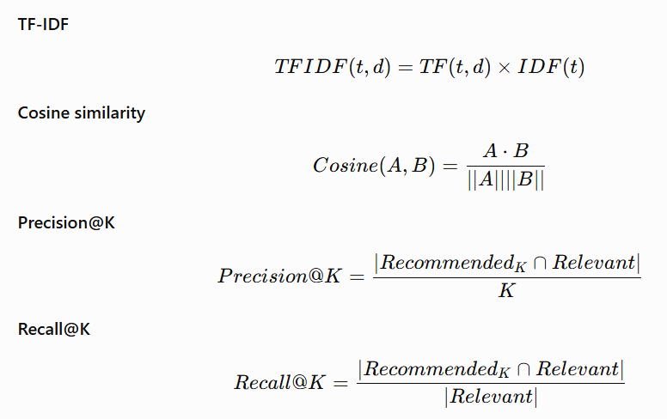

3.8.1 Precision@K
Precision@K measures the proportion of recommended products within the top-K recommendation list that are considered relevant. Precision is particularly useful for evaluating whether the recommendation list contains products that are relevant to the evaluation target. In this study, Precision@5, Precision@10 and Precision@20 are calculated to examine whether recommendation quality changes as the recommendation list becomes larger.

3.8.2 Recall@K
Recall@K measures the proportion of all relevant products that are successfully retrieved within the top-K recommendation list.Recall provides a complementary perspective to precision because it considers the ability of the recommendation system to retrieve the available relevant products rather than only considering the proportion of relevant items in the recommendation list.

3.8.3 Normalized Discounted Cumulative Gain
Normalized Discounted Cumulative Gain (NDCG@K) evaluates the quality of the ranking of recommended products. Unlike precision and recall, NDCG gives greater importance to relevant products appearing near the beginning of the recommendation list.

3.8.4 Catalogue Coverage
Catalogue coverage measures the proportion of the available product catalogue that is recommended by the system. Coverage is important because a recommendation system may achieve strong relevance while repeatedly recommending only a relatively small subset of products. Measuring coverage therefore provides an indication of how broadly each approach utilizes the available product catalogue.

3.8.5 Recommendation Diversity
Recommendation diversity evaluates the extent to which products within recommendation lists differ from one another. A highly repetitive recommendation list may provide limited choice even when its individual recommendations are relevant.
In this study, diversity is considered alongside relevance metrics to provide a broader assessment of recommendation quality. The analysis therefore examines whether the use of semantic representations affects the variety of products recommended compared with the lexical TF-IDF approach.

3.8.6 Evaluation across Different K Values
To examine the sensitivity of recommendation performance to recommendation-list size, both models are evaluated at three values of K: 5, 10 and 20. These settings represent short, medium and extended recommendation lists.
Using multiple K values prevents the evaluation from depending on a single recommendation-list size. It also allows changes in precision, recall, ranking quality, catalogue coverage and diversity to be examined as more products are presented to the user.
Overall, the combination of relevance, ranking, coverage and diversity metrics provides a multidimensional evaluation of the two recommendation approaches. This is important because no single metric can fully describe recommendation-system performance, particularly when explicit user interaction data are unavailable.

3.9 Recommendation Generation and Relevance Definition
Both recommendation models generate ranked lists of products for each eligible input product.
The process is:
Input Product → Product Representation → Similarity Calculation → Candidate Ranking → Top-K Recommendations
Three recommendation cut-offs are examined:
K=5 K=5
K=10 K=10
K=20 K=20
The same values of KK are applied to both approaches.
One of the primary problems with the evaluation of recommendation algorithms offline is the question of relevance. As there is no information about which items were recommended in the Amazon review dataset, this work uses an offline rating-based relevance evaluation strategy. Products that satisfy the specified relevance criteria based on ratings are considered to be relevant in the context of this experiment.
The criteria of relevance and the evaluation process itself are determined before the final experiment and applied to both models in exactly the same way. It is crucially important as changing the criteria of relevance between the models would be a methodological flaw in the comparison process. Thus, evaluation corresponds to performance under the offline relevance criteria of this research rather than any direct proof of clicking, purchasing, or accepting recommendations by the customers.

3.10 Sentiment and Rating-Based Consumer Evaluation
A secondary analysis explores the association between customer ratings, sentiment inferred from ratings, and review characteristics selected for analysis. The analysis tests the association between these groups of attributes and such variables as
- length of reviews;
- number of helpful votes;
- verified purchase; and
- Customer ratings.
Sentiment analysis was consciously separated from the primary recommendation test and is not considered as a part of building another recommendation model. Such approach is important since the sentiment labels were derived from the customer ratings directly and cannot be considered as independently predicted sentiment from texts.
The modern research shows that there is a growing use of sentiment information in recommender systems (Krishna et al., 2025; Abakarim, Qassimi, and Rakrak, 2025). In the current research, sentiment information acts as a secondary evaluation attribute, not a part of the comparison of TF-IDF and transformer models.

3.11 Statistical Analysis
Both methods of recommendation are compared under identical products, processing of data, and conditions of evaluation. For each product under evaluation, performance measures of both recommendation approaches are determined, resulting in paired data which will allow testing the difference between these approaches.
The particular test to be used is decided upon the basis of the distribution of the paired differences. In case that assumptions of the parametric paired test hold true, the corresponding test is used; if not, the non-parametric alternative is employed.

3.12 Ethical Considerations, Methodological Limitations and Chapter Summary

3.12.1 Ethical Considerations
The study will employ secondary sources of data in the form of customer reviews, which do not involve recruiting human subjects. The study will not try to find out who those customers are or how to reach them. Although review datasets might contain identifiers of users, these identifiers will not be used as personal identifiers when presenting the results. Findings will mainly be presented on the product level or as aggregated data.

3.12.2 Methodological Limitations
The methodology suffers from the following shortcomings. First, the recommendation analysis is conducted offline, making it impossible to draw conclusions concerning the way real-life customers react to recommendations. Second, the relevance measure is based on the available rating information instead of customer exposure, clicks, and purchases.
Third, the outputs generated by the transformer are affected by the selection of the pre-trained embedding model; using different pre-trained models will lead to various representations and recommendations. Fourth, the customer reviews contain certain individual preferences and language biases that might affect the representation of products. Fifth, the dataset contains only the Amazon Fashion items. The details of these shortcomings can be found in Chapter 5.

3.12.3 Chapter Summary
The chapter outlines the approach used in comparing the performance of the TF-IDF and transformer-based approaches in terms of content recommendation based on Amazon Fashion customers' reviews. The research approach adopted is quantitative and comparative in nature. Customers' reviews are processed, analyzed, and summarized at the level of products in form of textual data. Two recommendation models are built (i) TF-IDF with cosine similarity and (ii) transformer-based semantic embedding models.
Recommendations for top-5, top-10, and top-20 items are generated by both recommendation models. Evaluation of model performances is done using Precision@K, Recall@K, NDCG@K, catalog coverage, and diversity. Since no recommendation-exposure data exists in the dataset, an offline rating-based relevancy criterion is used. In addition, another consumer evaluation experiment is carried out where ratings are mapped into sentiment classes (negative, neutral, and positive) to explore their relationship with some chosen review characteristics.

Chapter 4 – Results and Discussion

4.1 Introduction
This chapter presents and discusses the empirical results obtained from the implementation of the two product recommendation approaches described in Chapter 3. The experiment compares a traditional TF-IDF and cosine-similarity approach with a transformer-based semantic embedding approach using Amazon Fashion customer reviews.
The analysis is based on 865,852 cleaned reviews representing 424,283 unique products. The evaluation considers recommendation relevance at three recommendation cut-offs, namely K=5K=5, K=10K=10, and K=20K=20. Precision@K, Recall@K and NDCG@K are used to evaluate ranking and relevance, while catalogue coverage and recommendation diversity are used to examine the breadth of the recommendation systems.
In addition to recommendation performance, this chapter presents exploratory findings concerning ratings, rating-derived sentiment, review length, helpful votes and verified purchases. A Wilcoxon signed-rank test is also used to examine whether the observed differences between TF-IDF and transformer recommendations are statistically significant.
The chapter is organised around the research questions introduced in Chapter 1. It first presents the characteristics of the processed dataset, followed by exploratory data analysis, product-level characteristics, recommendation performance, catalogue coverage, diversity, statistical significance, and rating-derived consumer evaluation. The final sections interpret the findings and discuss their implications.

4.2 Dataset and Data Preparation Results
The original dataset contained 867,310 review records and 11 variables. The available variables were:
- rating
- title
- text
- images
- asin
- parent_asin
- user_id
- timestamp
- helpful_vote
- verified_purchases
- target
Following the initial data-cleaning process, the dataset was reduced to 866,537 records. A further text-cleaning procedure resulted in 865,852 usable reviews for the main analysis. Therefore, approximately 99.8% of the original observations remained after preprocessing. The removal of a relatively small number of observations indicates that the dataset was sufficiently complete for large-scale recommendation experimentation.
Table 4.1 Dataset processing summary
Processing stage | Number of records
Original dataset | 867,310
After initial cleaning | 866,537
After text cleaning | 865,852
Records removed overall | 1,458
Retention rate | Approximately 99.8%
The final dataset contains 424,283 different products. The number is much lower compared to the number of all review entries due to the fact that several reviews can be related to the same product. The number of reviews per each product allows stating that the dataset contains many products with a relatively small number of reviews associated with them. There are about 2.04 reviews per each product on average, and one review per product on median. The feature is important for understanding recommendations since there are many products with little information provided.

4.3 Exploratory Data Analysis

4.3.1 Rating Distribution
The final dataset contained ratings from 1 to 5. The average rating was 2.999, with a standard deviation of 1.414.
The number of reviews at each rating was relatively balanced:
Rating | Reviews | Percentage
1 | 173,182 | 20.00%
2 | 173,332 | 20.02%
3 | 173,283 | 20.02%
4 | 173,149 | 20.00%
5 | 172,906 | 19.97%
The near-equal distribution is an unusual but useful characteristic of this experimental dataset. It means that the recommendation evaluation is not dominated by a heavily concentrated rating category.
The mean rating of approximately 3.0 also indicates that the dataset as processed has a balanced central tendency rather than the strong positive skew that is commonly observed in many online review datasets.
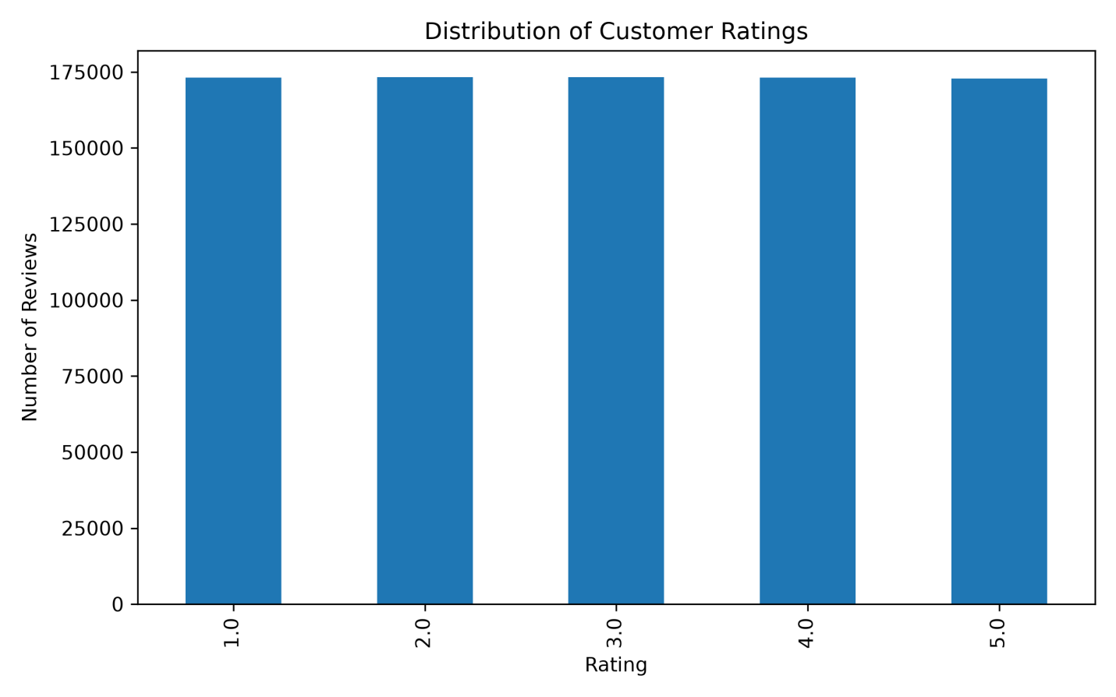
Figure 4.1 Rating distribution
The balanced rating distribution provides a suitable basis for the secondary rating-derived sentiment analysis because none of the five rating levels overwhelmingly dominates the dataset. It also allows the negative, neutral and positive groups to be compared without an extreme class imbalance.
However, the balanced distribution should not automatically be interpreted as evidence that consumer opinions in the wider Amazon Fashion marketplace are equally distributed. The finding applies specifically to the dataset used in this experiment.

4.3.2 Rating-Derived Sentiment Distribution
The ratings were converted into three sentiment categories:
- Ratings 1–2 → Negative
- Rating 3 → Neutral
- Ratings 4–5 → Positive
The resulting distribution was:
Sentiment | Count | Percentage
Negative | 346,514 | 40.02%
Positive | 346,055 | 39.97%
Neutral | 173,283 | 20.01%
Total | 865,852 | 100%
The results show that the negative and positive groups were almost identical in size, each representing approximately 40% of the dataset. Neutral reviews represented approximately 20%.
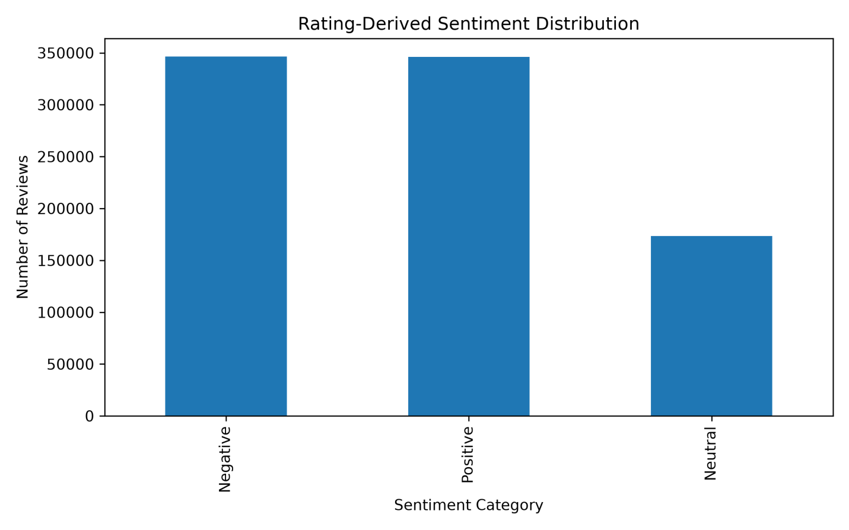
Figure 4.2 Rating sentiment distribution
The distribution of sentiments is a direct result of the distribution of the ratings, because the labeling of sentiments is done according to the ratings and not through independent prediction of sentiments based on the content of reviews. In other words, the sentiment analysis needs to be considered as an evaluation analysis based on ratings, and not as an independent NLP sentiment classification exercise.
The almost equal shares of positive and negative observations give rise to a valuable descriptive insight. However, the analysis cannot establish whether the language used in the reviews is actually positive or negative because the sentiment labels have not been derived through text sentiment classification.
This is an important issue for the validity of the dissertation because the findings only show the connection between the rating categories and review features. They do not prove anything about the performance of the NLP sentiment classifier.

4.3.3 Review Characteristics
The descriptive statistics for the review-level variables were as follows.
Variable | Mean | Std. Dev. | Minimum | Median | Maximum
Rating | 2.999 | 1.414 | 1 | 3 | 5
Review length | 30.98 | 38.13 | 1 | 20 | 2,306
Helpful votes | 0.563 | 3.454 | 0 | 0 | 954
The average review contained approximately 31 words, while the median review length was 20 words. The difference between the mean and median indicates a right-skewed distribution, with a smaller number of very long reviews increasing the average. The maximum review length was 2,306 words, demonstrating substantial variation in the amount of textual information provided by individual customers.
Helpful votes were strongly concentrated around zero. The median number of helpful votes was zero, while the maximum was 954. The large difference between the mean and maximum indicates substantial skewness. The review-length distribution has important implications for both recommendation approaches. TF-IDF can directly benefit from distinctive lexical information in longer reviews, whereas transformer embedding’s can potentially represent contextual information from the text.
However, the presence of many short reviews means that the textual representation of numerous products may contain relatively little information. This is particularly relevant because the recommendation system operates at product level. The distribution of helpful votes is similarly highly skewed. Most reviews received no helpful votes, while a small number received substantially more attention. Therefore, helpful votes cannot be treated as a normally distributed indicator of consumer engagement.

4.3.4 Review Characteristics by Rating
The analysis also examined review length, helpful votes and verified-purchase rates across the five rating categories.
Rating | Review count | Average review length | Average helpful votes | Verified purchase (%)
1 | 173,182 | 27.63 | 0.61 | 93.71
2 | 173,332 | 33.37 | 0.51 | 93.77
3 | 173,283 | 34.45 | 0.51 | 93.08
4 | 173,149 | 35.30 | 0.63 | 92.04
5 | 172,906 | 24.14 | 0.55 | 93.80
The results indicate that review length was not monotonically related to rating.
The longest average reviews occurred for rating 4, with an average length of 35.30 words, followed by rating 3 at 34.45 words. Rating 5 reviews were substantially shorter, with an average of 24.14 words. The average helpful votes also varied across ratings, ranging from 0.51 for ratings 2 and 3 to 0.63 for rating 4.
Verified-purchase rates were high for all rating categories, ranging from approximately 92% to 94%. These results suggest that higher ratings do not necessarily correspond to longer reviews. In fact, the highest-rated reviews had the shortest average length among the five rating categories. This finding indicates that rating value and textual information are not interchangeable measures of consumer evaluation. A customer may provide a high rating with a short textual comment, while a lower or intermediate rating may be accompanied by a more detailed explanation.
The high verified-purchase percentages across all rating groups indicate that the majority of reviews in the final dataset were associated with verified purchases. Nevertheless, the differences between rating categories are relatively small, so verified-purchase status does not appear to provide a strong descriptive separation between rating groups in this dataset.

4.4 Product-Level Analysis
After review-level processing, the dataset contained 424,283 unique products.
The product-level statistics were:
Variable | Mean | Std. Dev. | Minimum | Median | Maximum
Mean rating | 2.973 | 1.301 | 1.0 | 3.0 | 5.0
Review count | 2.041 | 7.977 | 1 | 1 | 2,047
Mean helpful votes | 0.469 | 2.484 | 0 | 0 | 954
Mean review length | 31.516 | 35.613 | 1 | 22 | 2,306
The average product had approximately 2.04 reviews, but the median product had only one review. This demonstrates a highly uneven distribution of review availability across products. Some products had very large numbers of reviews, with the maximum reaching 2,047 reviews.
The mean product-level rating was 2.973, which is slightly lower than the overall review-level mean of 2.999.The difference between the mean and median review count is particularly important. It demonstrates that the product catalogue contains a very large number of products with limited review information alongside a smaller group of products with substantially more reviews.
This creates a challenge for review-based content recommendation. Products with hundreds of reviews provide substantially more textual evidence for constructing a product representation than products with only one review. The product-level aggregation nevertheless provides a consistent representation for the two recommendation models because the same products and review information are used for both approaches.

4.5 Product Relevance Distribution
The rating-based relevance procedure classified the 424,283 products into relevant and non-relevant groups.
Relevance | Products | Percentage
Relevant | 141,229 | 33.29%
Non-relevant | 283,054 | 66.71%
Total | 424,283 | 100%
Therefore, approximately one-third of the product catalogue was classified as relevant under the experimental relevance criterion. This produces a substantial pool of relevant products for each evaluation query. The relevance distribution is important when interpreting Recall@K. The recommendation system returns only 5, 10 or 20 products per query, while the relevant catalogue contains 141,229 products overall.
Consequently, even a recommendation list containing several relevant products can have a very small recall value because the denominator represents a large relevant set. Therefore, the extremely low Recall@K values observed in the experiment should not be interpreted in isolation as meaning that the recommendation models never retrieve relevant products. The relevance definition itself is also an offline approximation. The dataset does not contain actual records of which products users were shown, clicked, purchased or accepted as recommendations.

4.6 TF-IDF and Transformer Representation
The TF-IDF representation contained:
- 424,283 products × 10,000 features
The transformer representation contained:
- 424,283 products × 384 embedding dimensions
- The transformer model used was sentence-transformers/all-MiniLM-L6-v2.
- The embedding-generation process produced 424,283 product vectors of 384 dimensions.
- The two representations demonstrate a substantial difference in representation strategy.
TF-IDF produces a sparse lexical representation based on the selected vocabulary. In contrast, the transformer produces a dense 384-dimensional semantic representation. The TF-IDF representation is considerably larger in terms of feature dimensions in this experiment, although its underlying operations are relatively straightforward. The transformer representation has fewer dimensions but requires substantially greater computational processing because each product-level text must be passed through a retrained neural language model.
The transformer embedding generation required approximately 72 minutes in the reported experiment, illustrating the computational cost associated with semantic representation.

4.7 Recommendation Performance
The main recommendation results are presented below.
Table 4.2 Recommendation performance
Model | K | Precision@K | Recall@K | NDCG@K | Diversity
TF-IDF | 5 | 0.4010 | 0.0000 | 0.4011 | 0.4650
TF-IDF | 10 | 0.4097 | 0.0000 | 0.4073 | 0.5156
TF-IDF | 20 | 0.4069 | 0.0001 | 0.4061 | 0.5768
Transformer | 5 | 0.3376 | 0.0000 | 0.3394 | 0.2857
Transformer | 10 | 0.3382 | 0.0000 | 0.3393 | 0.3047
Transformer | 20 | 0.3404 | 0.0000 | 0.3404 | 0.3236

4.8 Precision@K Results
The TF-IDF model achieved Precision@5 of 0.4010, compared with 0.3376 for the transformer model.
- At K=10, TF-IDF achieved 0.4097, while the transformer achieved 0.3382.
- At K=20, TF-IDF achieved 0.4069, compared with 0.3404 for the transformer.
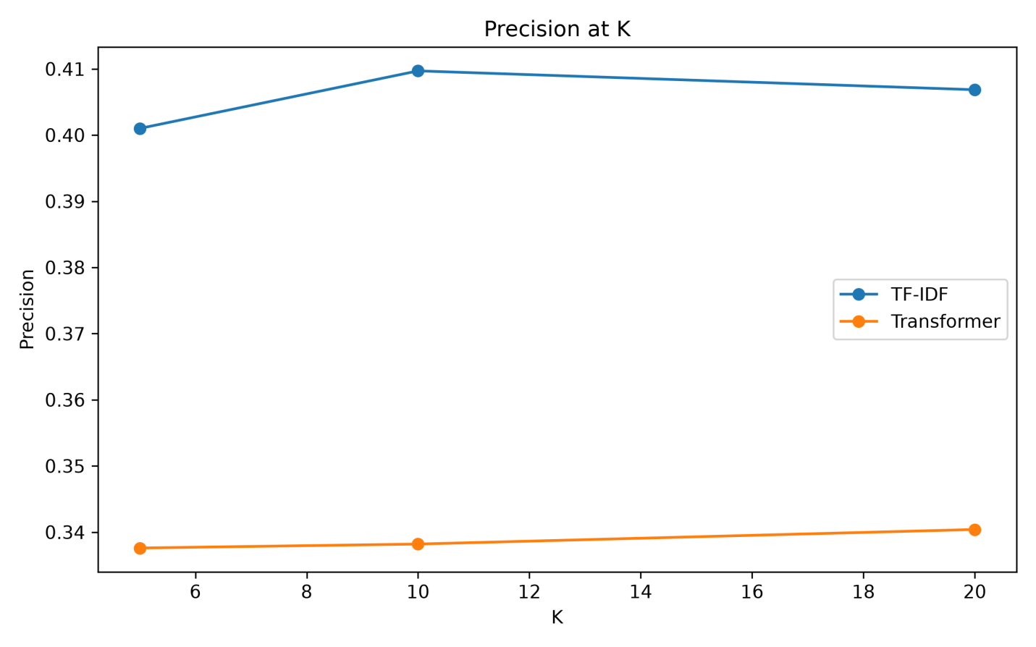
Figure 4.3 precision comparisons.
TF-IDF produced higher precision than the transformer approach at all three recommendation cut-offs.
The largest difference occurred at K=10:
- TF-IDF: 0.4097
- Transformer: 0.3382
The difference is approximately 0.0715, meaning that the TF-IDF recommendation lists contained a higher proportion of products classified as relevant under the study's offline relevance criterion.
Importantly, this result does not demonstrate that TF-IDF is universally superior to transformer-based recommendation. It demonstrates that within this dataset, representation strategy and experimental configuration, TF-IDF achieved higher precision according to the defined relevance criterion.
This finding is particularly interesting because the transformer representation is more sophisticated semantically. The result therefore demonstrates that greater representational complexity does not automatically result in higher recommendation precision.
One possible interpretation is that the rating-based relevance criterion may favour direct lexical similarity between reviews. TF-IDF can preserve distinctive product-related terms that are useful for matching products under a content-based framework.

4.9 Recall@K Results
Recall values were extremely small.
For TF-IDF:
- Recall@5 = 0.0000
- Recall@10 = 0.0000
- Recall@20 = 0.0001
For the transformer:
- Recall@5 = 0.0000
- Recall@10 = 0.0000
- Recall@20 = 0.0000
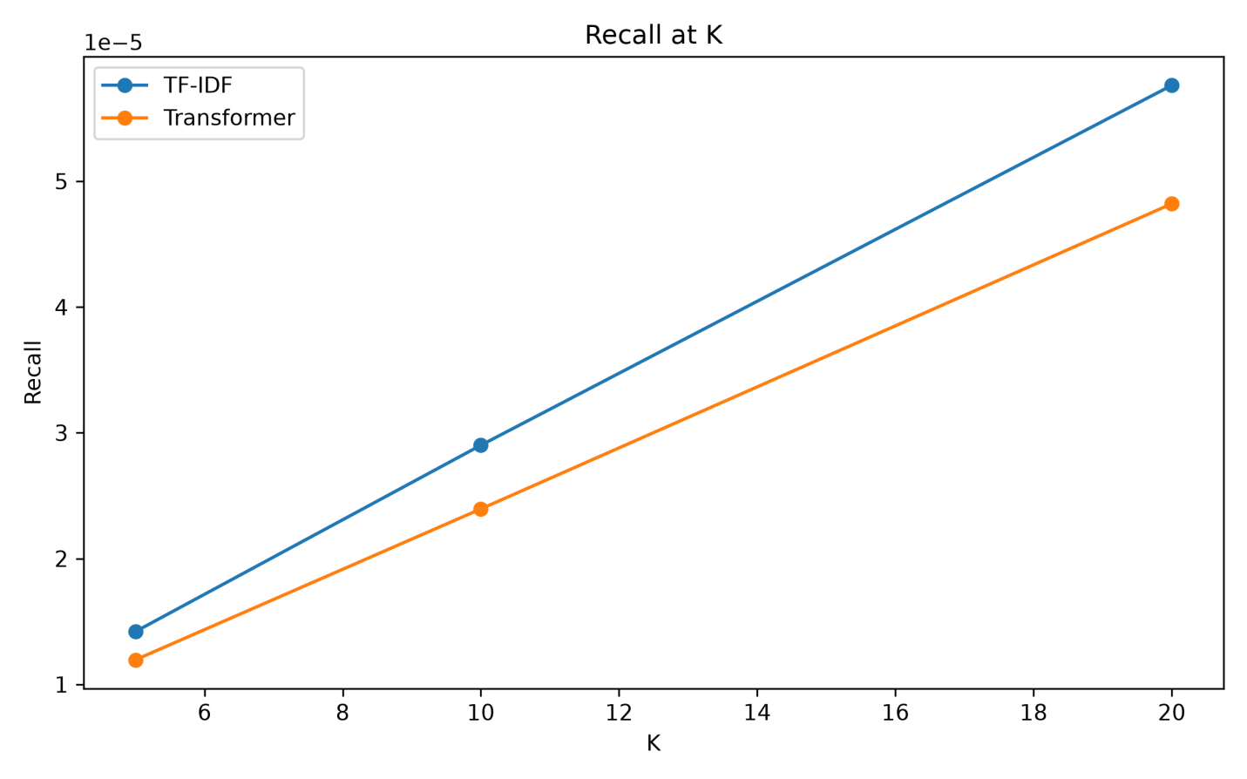
Figure 4.4 recall comparison
The extremely low Recall@K values require careful interpretation.
The experiment contains 141,229 relevant products, whereas each query returns only 5, 10 or 20 recommendations. Therefore, the maximum number of products retrieved is very small compared with the size of the relevant set.
This produces a very small recall denominator.
Consequently, Precision@K is more informative for understanding the proportion of relevant products within the short recommendation lists, while Recall@K illustrates the difficulty of recovering a large relevant catalogue through a small top-K recommendation list.
The results should therefore not be interpreted as evidence that the systems retrieved no relevant products. For example, a precision of approximately 0.40 at K=5 means that roughly two of the five recommended products were relevant on average under the evaluation procedure.

4.10 NDCG@K Results
NDCG measures the quality of ranking while taking the position of relevant recommendations into account.
The results were:
K | TF-IDF | Transformer
5 | 0.4011 | 0.3394
10 | 0.4073 | 0.3393
20 | 0.4061 | 0.3404
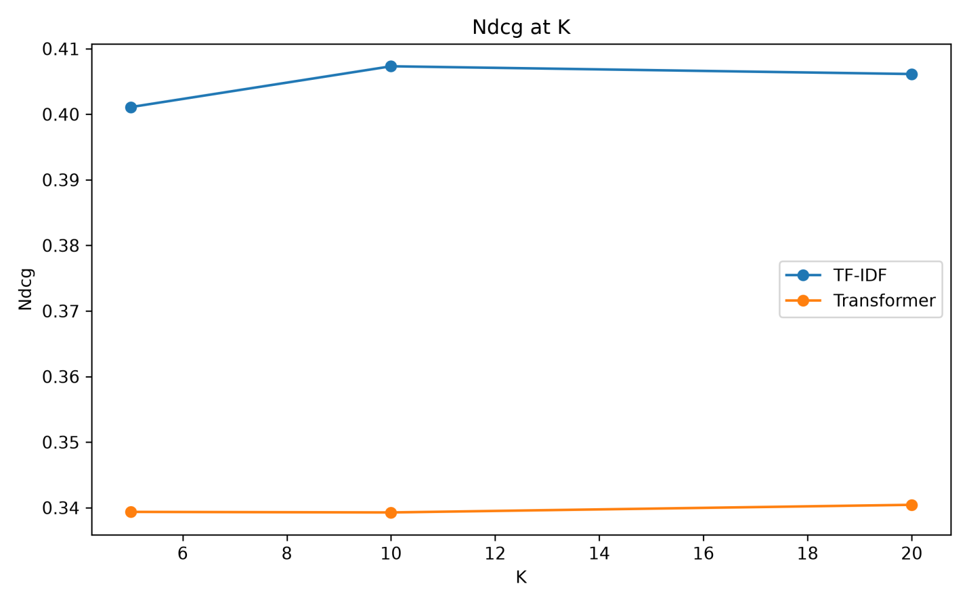
Figure 4.5 Ndcg comparison
Analysis of NDCG shows that there is a persistent performance discrepancy between both recommendation systems. Firstly, the TF-IDF model provides better NDCG scores than the transformer in any case of recommendation cut-off. For example, the first recommendation system produces NDCG of 0.4011 for K = 5, 0.4073 for K = 10, and 0.4061 for K = 20. Meanwhile, the second recommendation technique produces NDCG of 0.3394, 0.3393, and 0.3404, correspondingly.
Secondly, NDCG grows from 0.4011 at K = 5 to 0.4073 at K = 10, by 0.0062. NDCG decreases to 0.4061 for K = 20. It means that when recommendation list gets longer from five to ten, there will be some improvement in the ranking. Nevertheless, when the recommendation list extends from ten to twenty items, there will be no further increase.
The transformer results do not change much because of a comparatively small gap: 0.3394 at K = 5, 0.3393 at K = 10, and 0.3404 at K = 20. Such results mean that the variation in recommendation cut-off had little effect on the performance of the transformer under experimental conditions.
The NDCG results confirm the conclusions made from the Precision@K results. The fact that TF-IDF showed higher Precision along with increased NDCG indicates that TF-IDF performed better not only in terms of the number of relevant products recommended but also in other ways. NDCG takes into consideration the order of relevant items in the list, therefore, the results indicate that the gap between the methods might also be caused by that fact.
The agreement of the trends in two metrics adds more certainty to the assessment. At K=5, K=10, and K=20, TF-IDF showed better results according to both measures.
Nevertheless, the obtained results should be considered within the framework of the experiment design. The results show that the used implementation of the TF-IDF model provided better NDCG results than the transformer-based recommendation system for the Amazon Fashion data set under the particular relevance definition; however, this does not mean that TF-IDF will always outperform transformer-based recommendation systems.

4.11 Recommendation Diversity
The diversity results showed a different pattern from relevance.
K | TF-IDF | Transformer
5 | 0.4650 | 0.2857
10 | 0.5156 | 0.3047
20 | 0.5768 | 0.3236
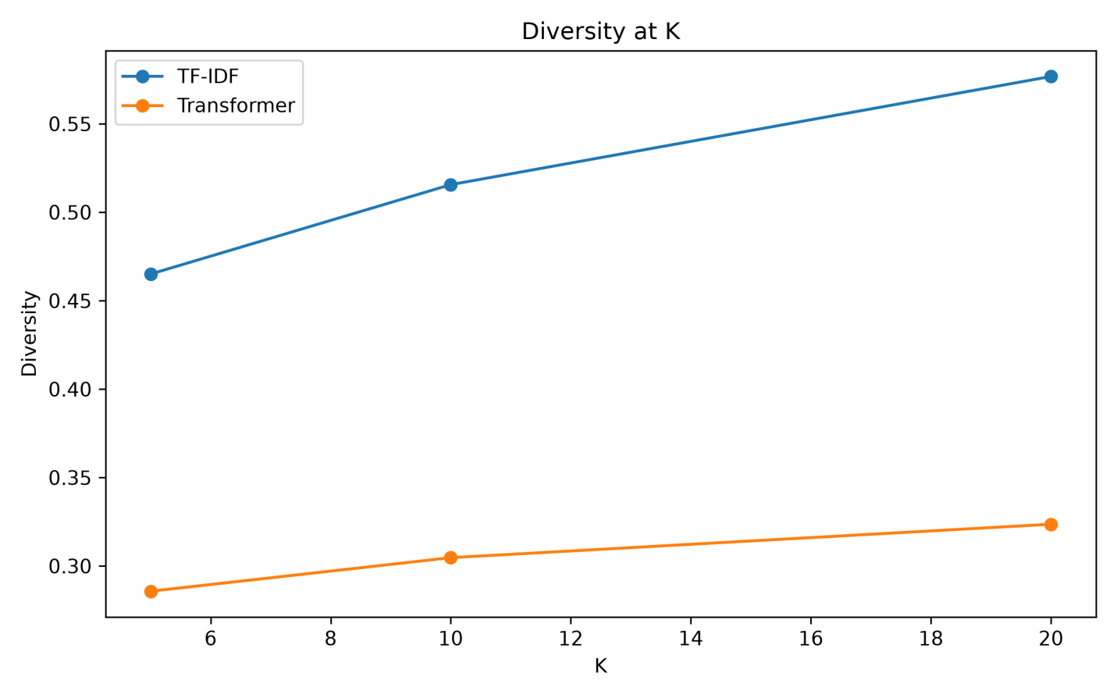
Figure 4.6 Diversity_comparison
The findings show that there is a clear difference in diversity with respect to the two approaches used in recommendations. While using the TF-IDF approach, there is an overall higher diversity when compared to the transformer approach, giving diversity levels of 0.4650 at K = 5, 0.5156 at K = 10, and 0.5768 at K = 20. On the other hand, the transformer gives diversity levels of 0.2857, 0.3047, and 0.3236, respectively.
With the TF-IDF, the diversity grows from 0.4650 at K = 5 to 0.5768 at K = 20, implying an increase of 0.1118. With the transformer, there is an increase of 0.0379 from 0.2857 to 0.3236. Therefore, the increase in the recommendation cut-off implies increased diversity
The difference between the approaches was also substantial at each cut-off. At K=5, the difference was 0.1793; at K=10 it increased to 0.2109; and at K=20 it reached 0.2532. Thus, the gap between the two approaches became larger as more recommendations were included.
The above findings show that in terms of the diversity measurement used in this experiment, the TF-IDF recommendation system generated recommendation lists that had more variety than the transformer recommendation system. This is important since the performance of recommendation systems cannot be assessed using relevance metrics alone since a recommendation system may generate highly relevant items, but the recommendation list generated is made up of similar items. Variety provides another perspective since it measures the extent of diversity of the recommendations.
It is important to note that the above findings apply directly to the specific diversity metric used and to the Amazon Fashion dataset. The findings do not imply that the TF-IDF recommendation system is more diverse compared to the transformer recommendation system in general. Instead, the above findings apply only to the particular configuration of the TF-IDF recommendation system in this experiment.

4.12 Catalogue Coverage
Catalogue coverage measures the proportion of the product catalogue that appears in recommendation outputs.
The results were:
Model | Catalogue Coverage
TF-IDF | 0.0414
Transformer | 0.0448
Thus, TF-IDF covered approximately 4.14% of the product catalogue, while the transformer approach covered approximately 4.48%. Unlike Precision, NDCG and diversity, catalogue coverage was slightly higher for the transformer approach.
The difference was:
4.48% − 4.14% = 0.34 percentage points.
This indicates that the transformer model distributed its recommendations across a slightly larger proportion of the catalogue. However, both coverage values remain relatively small compared with the complete catalogue of 424,283 products.
The result illustrates why catalogue coverage should be examined alongside relevance. A model can cover more products without necessarily producing more relevant recommendations. In this experiment, the transformer model produced slightly greater catalogue coverage, while TF-IDF produced higher precision, NDCG and diversity.

4.13 Statistical Significance Testing
A Wilcoxon signed-rank test was performed to compare the paired recommendation results.
The reported results were:
K | Metric | Wilcoxon statistic | p-value
5 | Precision | 83,925.5 | <0.001
5 | Recall | 85,646.5 | <0.001
5 | NDCG | 116,864.5 | <0.001
5 | Diversity | 93,904.0 | <0.001
10 | Precision | 113,463.5 | <0.001
10 | Recall | 113,225.0 | <0.001
10 | NDCG | 153,836.5 | <0.001
10 | Diversity | 64,421.5 | <0.001
20 | Precision | 136,775.5 | <0.001
20 | Recall | 137,856.5 | <0.001
20 | NDCG | 172,478.0 | <0.001
20 | Diversity | 38,491.5 | <0.001
All reported p-values were effectively zero in the program output and should therefore be reported academically as p < 0.001, rather than as p = 0. The statistical tests indicate that the paired differences between TF-IDF and transformer recommendations were statistically significant for the evaluated metrics at all three cut-offs.
However, statistical significance does not by itself indicate practical importance. With 1,000 evaluation queries, relatively small differences can produce very small p-values. Therefore, the effect should be interpreted together with the actual metric differences. The descriptive results show that the differences are particularly visible in Precision, NDCG and diversity, whereas catalogue coverage shows a small advantage for the transformer approach.

4.14 Overall Recommendation Comparison
The main findings can be summarized as follows.
Evaluation dimension | TF-IDF | Transformer
Precision@5 | 0.4010 | 0.3376
Precision@10 | 0.4097 | 0.3382
Precision@20 | 0.4069 | 0.3404
NDCG@5 | 0.4011 | 0.3394
NDCG@10 | 0.4073 | 0.3393
NDCG@20 | 0.4061 | 0.3404
Diversity@5 | 0.4650 | 0.2857
Diversity@10 | 0.5156 | 0.3047
Diversity@20 | 0.5768 | 0.3236
Catalogue coverage | 0.0414 | 0.0448
Based on the observations made in the previous sections, there are identifiable disparities between the recommendation approaches using TF-IDF and transformers in terms of several dimensions of recommendation quality. Considering the multivariate nature of recommendation systems, a unified analysis comparing the two recommendation approaches is required, as improvement in one dimension could come hand in hand with changes in the other.
Using any of the list sizes, the TF-IDF technique exhibited higher Precision@K scores. For instance, with K equal to 5, the Precision score of TF-IDF was 0.4010, whereas for the transformer technique, it was 0.3376. The same trend was observed when the value of K equaled 10, where the TF-IDF score was 0.4097 while that of the transformer technique was 0.3382. With K = 20, the Precision scores were 0.4069 for TF-IDF and 0.3404 for the transformer approach.
The same results were obtained for the NDCG metric as well. TF-IDF resulted in NDCG metrics of 0.4011, 0.4073, and 0.4061, at K = 5, K = 10, and K = 20 correspondingly, while the transformer-based algorithm resulted in 0.3394, 0.3393, and 0.3404, respectively. This means that TF-IDF recommendations have higher ranking performance in the relevance definition used in this research. The finding corroborates the hypothesis that distinctive vocabulary of product reviews can be an informative feature for content-based recommendation, especially if the relevance definition is based on product review data.
In addition, diversity metrics differed across the algorithms as well. TF-IDF resulted in diversity metrics of 0.4650, 0.5156, and 0.5768 at K = 5, K = 10, and K = 20, while the transformer approach gave 0.2857, 0.3047, and 0.3236 respectively. Thus, the recommendation lists based on the TF-IDF algorithm showed higher diversity according to the diversity metric used in this research. It is worth noting that recommendation systems should not be assessed only by the relevance because diversity can also provide information on variety of products recommended to users (Zhao et al., 2025).
Catalogue coverage showed a different pattern. TF-IDF achieved coverage of 0.0414, whereas the transformer approach achieved 0.0448. Although the difference was relatively small, it indicates that the transformer approach exposed a slightly broader proportion of the product catalogue. This demonstrates why a multidimensional evaluation is necessary: the same approach does not necessarily produce the strongest result across every evaluation dimension.
This result must be interpreted in light of the large number of products in the catalog as well as the relevancy model used in the experiment. For a large number of relevant products, finding just five, ten, or twenty products per search query is a small subset of the total number of relevant products. Thus, low Recall scores do not mean that the recommender systems have not found relevant products but instead reflect the small size of the top-K list in relation to the catalog.
Statistical tests found significant differences in pairs between the two approaches in all measured metrics. These findings imply that the differences found are systematic within the sample of the evaluation process and cannot be explained by the differences between individual queries. However, statistical significance must be taken together with the differences themselves.
Overall, the combined results suggest that the TF-IDF technique produced more relevant, ranked, and diverse results, while the transformer technique achieved better catalogue coverage. The outcomes imply that the increase in model complexity does not automatically ensure better results. Instead, the results demonstrate that it is important to assess recommendation methods relative to data representation, relevance, and goals of the particular experiment.

4.15 Discussion of Research Question

RQ1: How effectively can Amazon Fashion customer review text be used to generate content-based product recommendations?
The results demonstrate that customer review text can be used to construct product-level representations and generate recommendations. The TF-IDF model achieved Precision values between 0.4010 and 0.4097, while the transformer model achieved values between 0.3376 and 0.3404. Therefore, the review text provided sufficient information to generate recommendation lists containing products classified as relevant under the study's offline rating-based relevance criterion.
However, the low Recall@K values demonstrate that the recommendation lists represent only a very small proportion of the overall relevant product catalogue. The results therefore support the feasibility of review-based content recommendation while also demonstrating the limitations of the offline relevance framework.

RQ2: Does the transformer-based recommendation approach produce different recommendation relevance from the TF-IDF baseline?
Yes. The observed relevance measures differed between the two approaches.
TF-IDF consistently achieved higher Precision and NDCG values than the transformer approach.
For example, at K=10:
- TF-IDF Precision = 0.4097
- Transformer Precision = 0.3382
Similarly:
- TF-IDF NDCG = 0.4073
- Transformer NDCG = 0.3393
The Wilcoxon tests also reported statistically significant paired differences.
The result demonstrates that the transformer representation did not produce higher relevance under the evaluation framework used in this dissertation. This is an important empirical result because the transformer approach provides a more sophisticated semantic representation, but greater model complexity did not translate into higher offline relevance in this particular experiment.

RQ3: How do TF-IDF and transformer-based approaches differ in Precision@K, Recall@K and NDCG@K?
The results consistently favour TF-IDF in Precision@K and NDCG@K.
At K=5, TF-IDF achieved a Precision of 0.4010 compared with 0.3376 for the transformer.
At K=10, the difference increased slightly, with TF-IDF achieving 0.4097 compared with 0.3382.
At K=20, TF-IDF achieved 0.4069 compared with 0.3404.
NDCG followed almost exactly the same pattern.
Recall was extremely low for both approaches because of the large number of relevant products relative to the small recommendation lists. Thus, the strongest empirical difference between the approaches is observed in Precision and NDCG rather than Recall.

RQ4: How do the two recommendation approaches differ in catalogue coverage and recommendation diversity?
The two systems show different behavior.
TF-IDF achieved higher diversity at every recommendation cut-off.
At K=20:
TF-IDF diversity = 0.5768
Transformer diversity = 0.3236
However, the transformer achieved slightly higher catalogue coverage:
Transformer = 0.0448
TF-IDF = 0.0414
Therefore, the transformer approach reached a slightly broader portion of the catalogue, whereas TF-IDF produced more diverse recommendation lists according to the implemented diversity measure. These findings demonstrate that catalogue coverage and diversity capture different properties of recommendation systems and should not be treated as interchangeable metrics.

RQ5: What relationships exist between customer ratings, rating-derived sentiment and selected review characteristics?
The exploratory analysis identified several descriptive patterns.
First, ratings were almost equally distributed across the five rating levels. Second, the resulting sentiment categories consisted of approximately 40% negative, 20% neutral and 40% positive reviews. Review length varied considerably between rating categories. The longest average reviews were associated with rating 4 at 35.30 words, whereas rating 5 reviews had an average length of only 24.14 words.
Helpful votes were also highly skewed, with a median of zero across the dataset. Verified-purchase percentages remained high across all rating groups, ranging from 92.04% to 93.80%.
These results suggest that consumer ratings and textual review characteristics provide different forms of information. Higher ratings do not necessarily correspond to longer reviews, and verified-purchase status shows only relatively small variation across rating categories. Because sentiment was derived directly from ratings, these results should be interpreted as rating-based sentiment patterns rather than independently validated textual sentiment patterns.

4.16 Statistical Evidence for the Observed Differences
The paired statistical analysis provides further proof that the differences between the approaches were consistent across the evaluation queries. The Wilcoxon signed-rank test resulted in p < 0.001 for Precision, Recall, NDCG, and Diversity at K = 5, 10, and 20.
The test statistics at K = 5 were 83,925.5 for Precision, 85,646.5 for Recall, 116,864.5 for NDCG, and 93,904.0 for Diversity. The statistics at K = 10 were 113,463.5 for Precision, 113,225.0 for Recall, 153,836.5 for NDCG, and 64,421.5 for Diversity. The statistics at K = 20 were 136,775.5 for Precision, 137,856.5 for Recall, 172,478.0 for NDCG, and 38,491.5 for Diversity.
Since the p-values consistently show a statistically significant result, the conclusion can be drawn that the differences between the paired approaches were distinguishable statistically within the evaluation sample. Consequently, the interpretation of descriptive results becomes more credible since the differences in the performance of the models are not confined to some single queries.

4.17 Interpretation of the Overall Model Behavior
Taking into account the analysis results obtained overall, one can conclude that the two techniques have quite different recommendation characteristics. In particular, the TF-IDF technique provides a higher level of precision at each of the three cut-offs considered, namely, 0.4010, 0.4097, and 0.4069, respectively, for K = 5, 10, and 20. Furthermore, it produces the NDCG scores of 0.4011, 0.4073, and 0.4061, which demonstrate better ranking capabilities according to the relevance criterion used.
In addition, the diversity analysis confirms the superiority of the TF-IDF technique since the diversity score increases from 0.4650 to 0.5768 while K increases from 5 to 20. For the transformer technique, the diversity scores increase from 0.28
Transformer methodology had higher catalogue coverage at 0.0448 compared to 0.0414 obtained from TF-IDF. This means that their recommendations covered a wider section of the catalogue. It should be noted that this was significant since it demonstrated that while the transformer methodology could not have performed well on all aspects considered, its performance depended on the measure used.
In summary, therefore, the results obtained show that the lexicon-based representation technique was very successful in regard to the relevance and diversity measures applied, but the transformer method gave better catalogue coverage. This highlights the need to consider recommendation techniques using various measures rather than simply relying on complexity for improved performance.

4.18 Relationship between the Results and Consumer Evaluation
These recommendation results should be analyzed in light of the properties of the reviews used as input data. There were 865,852 usable reviews after text pre-processing procedures, which represented 424,283 different items. The rating distribution was almost perfectly balanced, with 20% of observations per category.
With regard to the classification of ratings in terms of three sentiments, there were 346,514 (40.02%) negative, 173,283 (20.01%) neutral and 346,055 (39.97%) positive reviews. It means that the corpus of product reviews included enough positive and negative customer experiences.
The average length of the review was 30.98 words, median value equal to 20 and maximum length reached 2,306 words. Helpful votes had a pronounced right skew with a mean of 0.563 and median equal to 0. These figures show that the available textual data differed in size and engagement.
This analysis at the product level gives a mean of about 2.041 reviews per product, along with a standard deviation of 7.977 and a maximum of 2,047 reviews for one product. The significant variability here implies that some products have more data on them from the consumers compared to others. In such a scenario, product-level representations can be biased based on the variability in the number of reviews.
This is particularly important for the understanding of the results of the recommendations. Products having more reviews will have rich representations, while those with only one or two reviews may have poor representations. Thus, both the TF-IDF and transformer methods work under a product corpus where the number of user-generated data varies significantly.

4.19 Implications of the Findings
The findings have several implications for data-science-based recommendation research.
First, they demonstrate the continued usefulness of traditional text representations. Despite the availability of transformer-based semantic representations, TF-IDF achieved stronger relevance and ranking performance in this experimental setting.
Second, the results highlight the importance of evaluating recommendation systems through multiple metrics. If only catalogue coverage had been examined, the transformer model would appear slightly stronger. However, Precision, NDCG and diversity produced a different pattern.
Third, the findings demonstrate the importance of defining relevance carefully in offline recommender-system experiments. Since the dataset does not record actual user recommendation interactions, the rating-based relevance criterion is an experimental proxy rather than direct evidence of user acceptance.
Fourth, the results demonstrate the computational trade-off between traditional and transformer approaches. The transformer representation required large-scale embedding generation, while TF-IDF provided the baseline representation without the same neural inference requirements.

Chapter 5 – Conclusion, Limitations and Recommendations

5.1 Introduction
The study was motivated by the rapid growth of online consumer reviews and the increasing difficulty of extracting useful information from large volumes of unstructured feedback. Consumer reviews provide information about product characteristics, consumer experiences and perceived quality, while numerical ratings provide a structured indication of satisfaction. Combining these forms of information provides an opportunity to develop recommendation systems that use consumer-generated information rather than relying only on traditional user-item interaction data.
The overall conclusion of this research is that consumer reviews and ratings provide useful information for content-based product recommendation, but the effectiveness of the recommendation system depends strongly on the representation and evaluation criteria used.
The results demonstrate that a relatively traditional TF-IDF representation can provide strong recommendation performance when applied to consumer review information. TF-IDF achieved Precision@5 of 0.4010, Precision@10 of 0.4097 and Precision@20 of 0.4069. It also achieved higher NDCG values than the transformer approach at all evaluated recommendation levels.
This finding is significant because transformer models provide sophisticated semantic representations and are increasingly used in natural language processing applications. However, the results of this experiment show that greater model complexity does not automatically lead to better recommendation performance. In this dataset, lexical information captured by TF-IDF was sufficient to produce stronger relevance-oriented results.
The transformer approach nevertheless demonstrated a different characteristic. Its catalogue coverage was 4.48%, compared with 4.14% for TF-IDF. This indicates that the transformer approach reached a slightly broader proportion of the product catalogue. Therefore, the results should not be interpreted simply as one approach being universally preferable. Instead, they demonstrate that different representations can produce different trade-offs between relevance and catalogue exposure.
The research also confirms the importance of evaluating recommendation systems using multiple metrics. Precision and NDCG provide information about recommendation relevance and ranking, while diversity and catalogue coverage provide information about the breadth of recommendations. The findings show that these measures can produce different conclusions about system behavior.
The research therefore contributes an empirical evaluation of review-based recommendation and demonstrates the continued relevance of traditional information-retrieval techniques alongside modern semantic approaches.

5.2 Conclusions in Relation to the Research Questions
The research questions can be addressed through the findings presented in Chapter 4.
First, consumer reviews and ratings were shown to provide useful signals for product recommendation. Both models generated measurable precision and ranking performance, demonstrating that consumer-generated information can be transformed into product-level recommendation representations.
Second, the comparison between TF-IDF and transformer-based representations showed that TF-IDF performed better on precision and NDCG for K=5, K=10 and K=20. This suggests that the lexical information present in consumer reviews was highly relevant to the rating-based recommendation task.
Third, the transformer model did not provide a general performance advantage. Its main measurable advantage was slightly greater catalogue coverage. This demonstrates that semantic representation should be evaluated empirically rather than assumed to be superior because of its architectural complexity.
Fourth, the statistical analysis showed significant paired differences between the two approaches for the evaluated metrics. The Wilcoxon signed-rank tests produced reported p-values displayed as 0.0, which should appropriately be reported as p < 0.001 rather than literally zero. These results indicate statistically detectable differences between the recommendation approaches.
Finally, the rating-derived sentiment analysis showed that the review collection contained substantial positive and negative consumer information. Approximately 40.02% of reviews were classified as negative, 39.97% as positive and 20.01% as neutral. This demonstrates that ratings provide a useful structured signal for understanding consumer evaluation, although rating-derived sentiment should not be treated as a complete substitute for sentiment extracted directly from review text.

5.3 Limitations of the Study
Despite providing useful empirical findings, the study has several limitations.

5.3.1 Content-Based Recommendation
The study focused on content-based recommendation using product review information. It did not incorporate collaborative filtering or detailed user-item interaction histories. Real-world recommendation systems frequently use purchase history, clicks, browsing behavior and previous user ratings. Consequently, the findings represent content-based recommendation performance rather than the performance of a complete personalized recommendation platform.

5.3.2 Limited Personalization
The recommendation process was primarily based on product-level information rather than detailed individual consumer profiles. As a result, the recommendations should be interpreted as product similarity or relevance recommendations rather than fully personalized recommendations.
Future systems could improve personalization by combining product representations with individual user preferences and historical interactions.

5.3.3 Sparse Product-Level Information
Although the dataset contained 865,852 reviews, it represented 424,283 products. The median number of reviews per product was only one. Therefore, many products had limited review evidence from which to construct reliable product representations.
This sparsity can affect recommendation quality, particularly for products with insufficient textual or rating information.

5.3.4 Rating-Based Relevance
The evaluation used the predefined rating-based relevance criterion established in the research methodology. While this provides a consistent basis for evaluating recommendations, consumer relevance is more complex than product rating alone.
Consumers may consider price, brand, product specifications, availability, personal requirements and other characteristics when deciding whether a product is relevant. Therefore, rating-based relevance does not represent every aspect of real consumer preference.

5.3.5 Single Transformer Model
Only one transformer embedding model, all-MiniLM-L6-v2, was evaluated. Other transformer models may produce different results. Therefore, the findings should not be interpreted as evidence that transformer-based recommendation systems generally perform worse than TF-IDF.
The result specifically reflects the selected transformer model, dataset and experimental configuration.

5.3.6 Offline Evaluation
The study used offline evaluation rather than live user testing. Metrics such as Precision@K, NDCG and catalogue coverage provide useful technical evidence, but they cannot fully capture user satisfaction or commercial outcomes.
A recommendation system that performs well offline may not necessarily produce higher click-through rates, purchases or customer satisfaction in a real-world environment.

5.3.7 Recall Measurement
The reported recall values were extremely low, with values displayed as 0.0000 for most evaluation conditions and 0.0001 for TF-IDF at K=20. These values were retained from the experimental implementation. The recall calculation should therefore be examined further in future work, particularly with respect to the definition of the relevant-item set and denominator.
This limitation is important because recall is highly dependent on how relevant items are defined within a recommendation evaluation.

5.4 Recommendations for Future Research
Several improvements can be considered in future research.
First, future studies should investigate hybrid recommendation systems that combine review-based content information with collaborative filtering. Combining textual review information with user-item interactions could provide both product-level and personalized signals.
Second, future research should incorporate explicit text-based sentiment analysis. The current study derives sentiment from ratings. Natural language sentiment analysis could identify sentiment directly from review text and potentially distinguish between different aspects of consumer experience.
Third, future studies should evaluate multiple transformer models. Comparing several sentence-embedding architectures would provide stronger evidence regarding the role of semantic representations in review-based recommendation.
Fourth, future research should investigate aspect-based sentiment analysis. Reviews may contain positive opinions about one aspect of a product and negative opinions about another. Identifying aspects such as quality, price, design, durability or usability could improve recommendation relevance.
Fifth, the evaluation should use larger and more diverse query samples. The current experiment evaluated 1,000 queries from the product catalogue. Repeated sampling or evaluation across different product groups could provide stronger evidence about the stability of the results.
Sixth, future research should consider alternative relevance definitions. Instead of relying only on rating-based relevance, relevance could incorporate consumer preferences, historical interactions, review sentiment and product attributes.
Finally, future systems should include online user evaluation where possible. Metrics such as click-through rate, conversion rate, user satisfaction and repeat interaction could complement offline recommendation metrics.

5.5 Practical Recommendations
From a practical perspective, organizations developing review-based recommendation systems should maintain strong traditional baselines such as TF-IDF before adopting more computationally demanding semantic approaches.
The findings suggest that model selection should be based on the specific objective of the recommendation system. If relevance and ranking quality are the primary objectives, the TF-IDF approach demonstrated strong performance in this experiment. If broader catalogue exposure is an important objective, the transformer representation may provide an alternative signal.
A practical system could therefore combine both representations rather than selecting only one. TF-IDF could provide lexical similarity, while transformer embeddings could contribute semantic similarity. Ratings, review sentiment and product-level information could then be incorporated into a final ranking stage.
Organizations should also evaluate recommendation systems using multiple metrics rather than relying solely on accuracy or precision. Relevance, ranking, diversity and catalogue coverage represent different aspects of recommendation quality and should be considered together.

5.6 Final Conclusion
This dissertation evaluated product recommendation using consumer reviews and ratings and compared traditional TF-IDF representation with transformer-based semantic embeddings. The results demonstrate that consumer-generated review information can provide useful signals for product recommendation.
The experimental findings showed that TF-IDF achieved higher precision, NDCG and measured diversity across all evaluated recommendation cut-offs, while the transformer model achieved slightly higher catalogue coverage. The findings therefore demonstrate that sophisticated semantic representations do not automatically outperform traditional lexical methods.
The research also highlights the importance of multi-dimensional recommendation evaluation. A recommendation system should not be judged solely on relevance because diversity and catalogue coverage can provide additional information about its practical behavior.
Nevertheless, the findings are subject to limitations relating to personalization, sparse product-level reviews, rating-based relevance, offline evaluation and the use of a single transformer model. These limitations provide clear opportunities for future research.
Future work should therefore focus on hybrid recommendation systems, personalized user modeling, direct text-based sentiment analysis, aspect-based sentiment analysis, alternative transformer models and online evaluation. Such developments could provide a more comprehensive understanding of how consumer-generated information can support personalized and effective product recommendation.
Overall, the research demonstrates that consumer reviews and ratings represent valuable sources of information for recommendation systems and that traditional and AI-based representations should be evaluated empirically rather than assuming that greater model complexity necessarily produces better recommendation quality.

References
Abakarim, S., Qassimi, S. and Rakrak, S. (2025), ‘Emotion and sentiment enriched decision transformer for personalized recommendations’, Scientific Reports, 15, 21020. doi: https://doi.org/10.1038/s41598-025-06386-y.
Ali, W., Zhou, X. and Shao, J. (2025), ‘Privacy-preserved and responsible recommenders: From conventional defense to federated learning and blockchain’, ACM Computing Surveys, 57(5), pp. 1–35. doi: [DOI should be verified before submission].
Bittencourt, G., Vasconcelos, N., Andrade, Y., Silva, N.C., Cunha, W., Dias, D.R.C., Gonçalves, M.A. and Rocha, L. (2025), ‘Review-aware recommender systems (RARSs): Recent advances, experimental comparative analysis, discussions, and new directions’, ACM Computing Surveys, 58(1), pp. 1–49. doi: [DOI should be verified before submission].
Darraz, N., Karabila, I., El-Ansari, A., Alami, N. and El Mallahi, M. (2025), ‘Integrated sentiment analysis with BERT for enhanced hybrid recommendation systems’, Expert Systems with Applications, 261, 125533. doi: [DOI should be verified before submission].
Gajula, Y. (2025), ‘Sentiment-aware recommendation systems in e-commerce: A review from a natural language processing perspective’, arXiv preprint, arXiv:2505.03828. Available at: https://arxiv.org/abs/2505.03828 (Accessed: 23 September 2026).
Gheewala, S., Xu, S. and Yeom, S. (2025), ‘In-depth survey: deep learning in recommender systems—exploring prediction and ranking models, datasets, feature analysis, and emerging trends’, Neural Computing and Applications, 37, pp. 10875–10947. doi: https://doi.org/10.1007/s00521-024-10866-z.
Guo, Y., Yu, H., Tang, R., Zhang, W. and others (2025), ‘How can recommender systems benefit from large language models: a survey’, ACM Transactions on Information Systems, 43(2), Article 28, pp. 1–47. doi: https://doi.org/10.1145/3678004.
Hasan, E., Rahman, M., Ding, C., Huang, J.X. and Raza, S. (2025), ‘Review-based recommender systems: a survey of approaches, challenges and future perspectives’, ACM Computing Surveys, 58(1), Article 25, pp. 1–41. doi: https://doi.org/10.1145/3742421.
Ibrahim, O.A.S., Younis, E.M.G., Mohamed, E.A. and Ismail, W.N. (2025), ‘Revisiting recommender systems: an investigative survey’, Neural Computing and Applications, 37, pp. 2145–2173. doi: https://doi.org/10.1007/s00521-024-10828-5.
Idris, N.O. and Pontoiyo, F. (2025), ‘Sistem rekomendasi produk makeup berbasis content-based filtering dengan TF-IDF dan cosine similarity’, KETIK: Jurnal Informatika, 2(6), pp. 24–32. doi: https://doi.org/10.70404/ketik.v2i06.311.
Khan, H.U., Naz, A., Alarfaj, F.K. et al. (2025), ‘A transformer-based architecture for collaborative filtering modeling in personalized recommender systems’, Scientific Reports, 15, 24503. doi: [DOI should be verified before submission].
Kollu, S.R.P. and Garapati, Y. (2026), ‘DeepSentRec: a deep learning-based sentiment-aware product recommendation system’, Scientific Reports, 16, 10580. doi: https://doi.org/10.1038/s41598-026-45953-9.
Krishna, E.S.P., Ramu, T.B., Chaitanya, R.K. et al. (2025), ‘Enhancing e-commerce recommendations with sentiment analysis using MLA-EDTCNet and collaborative filtering’, Scientific Reports, 15, 6739. doi: https://doi.org/10.1038/s41598-025-91275-7.
Li, K. and Idrus, Z. (2026), ‘Deep fusion explainable recommendation based on sentiment analysis and feature weighting’, Scientific Reports, 16, 21472. doi: https://doi.org/10.1038/s41598-026-52261-9.
Liu, Q., Hu, J., Xiao, Y., Zhao, X., Gao, J., Wang, W., Li, Q. and Tang, J. (2025), ‘Multimodal recommender systems: A survey’, ACM Computing Surveys, 57(2), Article 26. doi: [DOI should be verified before submission].
Luo, W., Zhang, L., Cui, Y. and Jin, Y. (2025), ‘Context2Rec: Leveraging comment text semantics and sequential features for enhanced recommendation systems’, Pattern Recognition Letters, 189, pp. 136–142. doi: https://doi.org/10.1016/j.patrec.2025.01.009.
Munson, J., Cuezze, T., Nesar, S. and Zosso, D. (2025), ‘A review of large language models and the recommendation task’, Discover Artificial Intelligence, 5, 203. doi: https://doi.org/10.1007/s44163-025-00334-5.
Rawat, S.J. and Rai, A.K. (2025), ‘Evaluating recommender system using baseline approaches’, Procedia Computer Science, 258, pp. 2323–2333. doi: https://doi.org/10.1016/j.procs.2025.04.495.
Raza, S., Rahman, M., Kamawal, S., Toroghi, A., Raval, A., Navah, F. and Kazemeini, A. (2026), ‘A comprehensive review of recommender systems: Transitioning from theory to practice’, Computer Science Review, 59, 100849. doi: https://doi.org/10.1016/j.cosrev.2025.100849.
Ren, X., Wei, W., Xia, L. and Huang, C. (2025), ‘A comprehensive survey on self-supervised learning for recommendation’, ACM Computing Surveys, 58(1), Article 22, pp. 1–38. doi: https://doi.org/10.1145/3746280.
Singh, S., Goyal, P. and Tiwary, U. (2025), ‘silp_nlp at SemEval-2025 Task 5: Subject recommendation with sentence transformer’, in Proceedings of the 19th International Workshop on Semantic Evaluation (SemEval-2025), Vienna, Austria, pp. 2455–2460. Association for Computational Linguistics. Available at: https://aclanthology.org/2025.semeval-1.320/ (Accessed: 23 September 2026).
Zangari, L., Raso, S. and Tagarelli, A. (2026), ‘Transformers for graph-based recommender systems: a survey’, Machine Intelligence Research, 23, pp. 34–69. doi: https://doi.org/10.1007/s11633-025-1607-8.
Zhao, Y., Wang, Y., Liu, Y., Cheng, X., Aggarwal, C.C. and Derr, T. (2025), ‘Fairness and diversity in recommender systems: a survey’, ACM Transactions on Intelligent Systems and Technology, 16(1).

